The Library Guest Speaker Program 2015, presents: Scot Gardner. Scot will present 2 sessions during BookWeek for years 7-9 in the College Library on: Monday, 24th August 2015, Periods 1 & 2.
Scot Gardner is an author, storyteller and performer. His 13 novels to date range from absurd fantasy for children to gritty realism and tragic-comedy for young adults. Scot’s works include novels such as: One Dead Seagull, White Ute Dreaming, The Legend of Kevin the Plumber, The Lost King, Happy as Larry, The Dead I Know and Burning Eddy which was short-listed for both the CBCA and NSW Premier's Literary Awards.
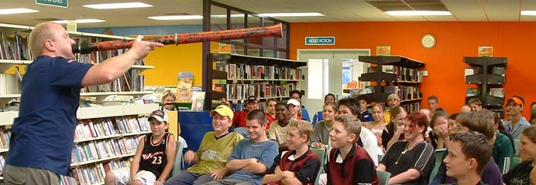
Scot was born in the Melbourne suburb of Greensborough and moved to the country with his family when he was twelve. His teenage years were spent in the Gippsland bush, where I still lives. Scot came to writing via counseling and youth work: “I wasn’t born reading and writing; I’ve worked as a waiter, masseur, delivery truck driver, home dad, counsellor and musician. I’m also licensed to handle explosives and venomous snakes!”
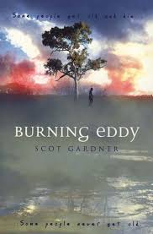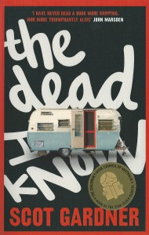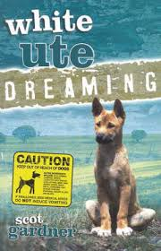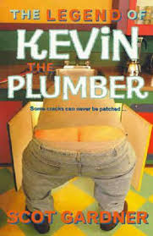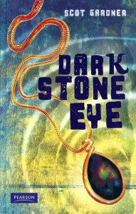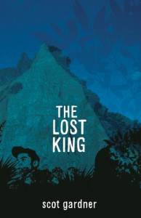
“I’m not even sure how I ended up a writer” says Scot.” I wanted to be a veterinarian when I was at school, but I did work experience as a vet and it was nothing like I’d imagined - most of the critters I saw were about to be put down. I didn’t have the heart for that as a kid, so I became a gardener. Scot Gardner, the gardener. I studied massage while working as a landscaper then studied counselling and psychotherapy while I was working as a masseur. I lived for a time on money I earned playing Didjeridu. I’ve waited tables and driven trucks, been a youth worker and a secondary school teacher. See what I mean? Not exactly a straight line.
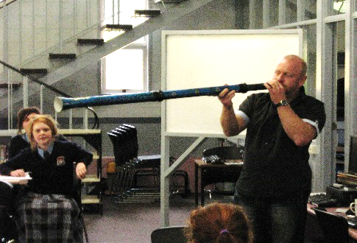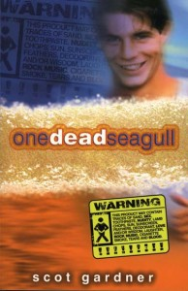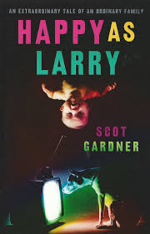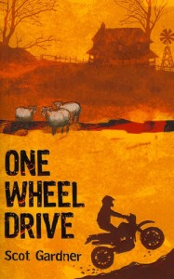
Scot's books centre on the theme of growing up, especially the teenage years. Having worked extensively with disadvantaged teenagers Scot has some insight into the problems faced by high risk teenagers, especially young men and Aboriginal youths. Scot lives with his wife and three children, two dogs and some chooks in the bush in Eastern Victoria. He spends half the year writing and half the year on the road talking to mostly young people about his books and the craft of writing.

The informational content in this promotion is derived from the following online sources: http://scotgardner.com/ ; http://bookedout.com.au/find-a-speaker/author/scot-gardner/ ; https://www.allenandunwin.com/default.aspx?page=311&author=450 Pictorial content used in this promotion is solely for the promotion of a single non-profit school based educational event. Compiled and edited by Andy McLuckie, 2015.

