All Australian 2001
Mark of the Year 2006
Premierships: 2007, 2009, 2011
___________________________________________________________________________________________________________
Brad Ottens: Born 25 Jan 1980
Height: 202 cm Weight: 108 kg
Senior clubs: Richmond, Geelong
Games 245 Goals 261
Hey Fans!

Brad Ottens, three time AFL premiership player will be speaking in the Lyndale College Library on Sept 18, 2014.

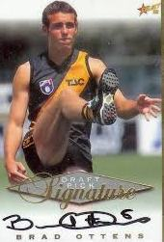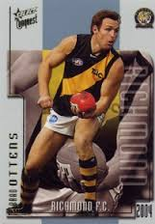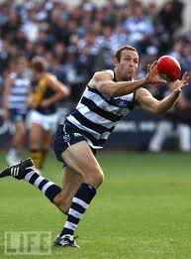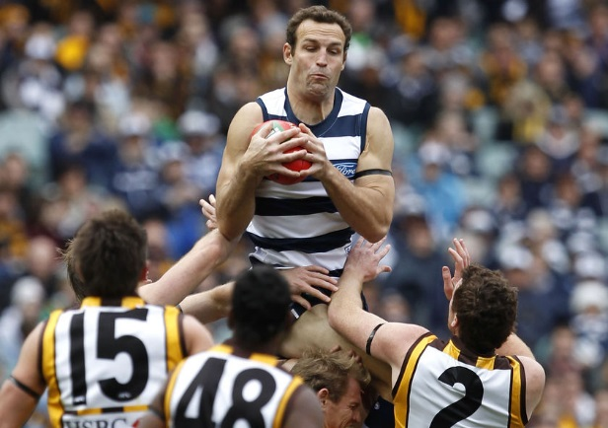

Brad Ottens had a long distinguished career as ruckman/forward with two AFL clubs Richmond 1998 -2004 and Geelong 2005-2011. Brad played an impressive total of 245 AFL games and kicked 261 goals.

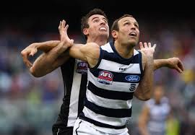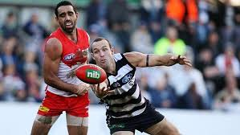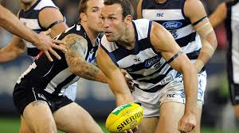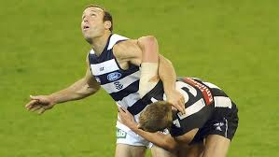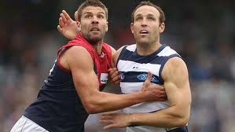

Brad’s career included many highlights. He was an AFL All Australian in 2001.
In 2006 Brad won the Mark of the Year and in 2007, 2009, and 2011 Brad played in some great Geelong Premiership teams.

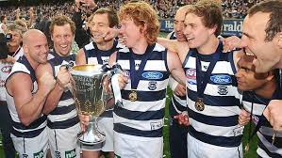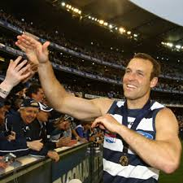

Brad Ottens jumped straight into specialist coaching after retiring following the 2011 premiership win. He re-joined the Cats as ruck coach in 2012 and along with former teammate Tom Harley took on a coaching role with the NSW/ACT Rams under 18 squad. Speaking of their newly formed coaching association Harley declared:” Brad is the sort of person footy needs. He is one of the smartest footballers I played with. People like Brad will help grow the code."

