With great pleasure and enthusiasm, we announce that our seventh guest for this year and our third author for Book Week will be acclaimed writer, teacher and lawyer, Alice Pung.
Lyndale teachers and our senior English students in particular will know that Alice is the editor of the book-listed anthology: Growing up Asian in Australia. (2008)
Alice is coming to Lyndale Secondary College Library to speak to students and staff about her life and her work on Tuesday, August 26, during period two. (10:40 and 11:30pm)
If you would like to see Alice speak (and especially if you would like to bring your class), please let Andy McLuckie or Mary Koutras know ASAP as bookings are essential.

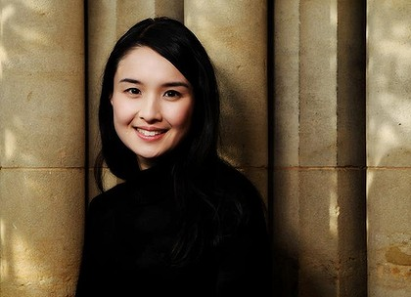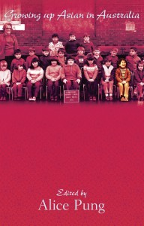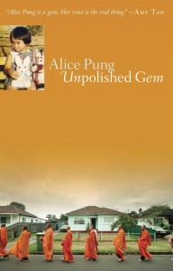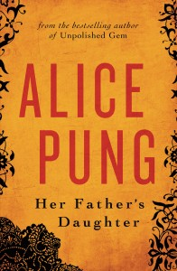
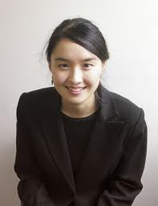

Alice Pung is a writer, lawyer and teacher. She was born in Footscray and grew up in Braybrook, attending local primary and secondary schools in the Western suburbs.
The author of Her Father’s Daughter and Unpolished Gem and the editor of Growing up Asian in Australia, Alice has received enormous critical acclaim for her writing.
Unpolished Gem won the 2007 Australian Newcomer of the Year award in the Australian Book Industry Awards and was shortlisted for several other awards including the Victorian Premier’s Literary Awards, the New South Wales Premier’s Literary Awards and The Age Book of the Year 2007.

Alice has worked extensively with both primary and secondary school students and is currently the writer ambassador for Room to Read and on the board of 100 Story Building.
Alice has a deep passion and empathy for youth issues, and believes in the power of good humor (and not-so-good puns) to help surmount adversity.
A qualified legal practitioner, she currently works in the area of minimum wages part time. The rest of her time she devotes to writing and school visits.

Images and biographical information regarding Alice Pung have been sourced from Alice’s official website: http://alicepung.com/blog/
Compiled & edited by A. McLuckie, 2014

