Autobiographical text and images on this page are from http://www.samriggio.com/ Edited by A.McLuckie, 2014.
Our fourth guest speaker for 2014 is Sam Riggio. Sam is a motivational speaker with a difference.
In 1999 a car accident left Sam paralysed from the neck down. Doctors told Sam and his family that he would never walk again. After being in a wheelchair for 8 years Sam took over his own care and taught himself to walk again. It was then Sam knew he had to help others through life's hurdles and use his knowledge and life experience to fast track other people in what they want to achieve. Sam now has a certificate IV in fitness, he is an experienced motivational speaker and he now looks forward to helping others achieve through Life & Business Coaching.
Sam Riggio will be our special guest in the College Library on June 12, 2014. Please come along and hear Sam speak if you can.

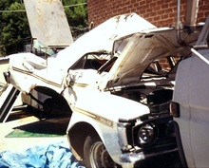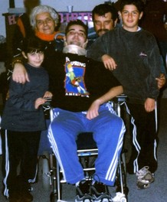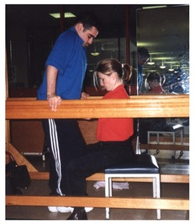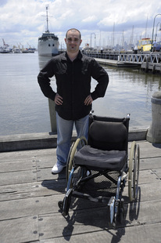
After a horrific car accident, Sam is left paralysed from the neck down. Doctors told Sam's parents he only had a 50-50 chance of survival.

Sam’s miracle of walking again comes to life as months of hard work pays off. After 14 months and 10 days Sam leaves hospital.

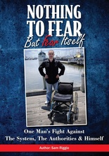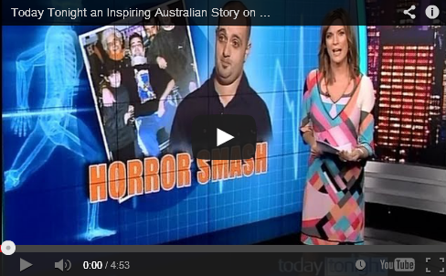
Sam’s Story on Today Tonight
All text and images on this page are from http://www.samriggio.com/ Edited by A.McLuckie, 2014

