Phillip Gwynne’s first novel Deadly Unna? was the literary hit of 1998 winning Children’s Book of the Year and selling over 200,000 copies. It was made into the feature film Australian Rules for which Phillip’s screenplay won an AFI award in 2002. In both works Australian Rules football provides the backdrop for an exploration of race relations in small town South Australia.

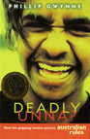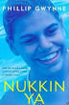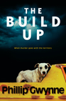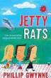

Phillip grew up in rural areas in Victoria and South Australia. He graduated from James Cook University with a degree in Marine Biology. Phillip played professional football for a while and then worked as a marine biologist in the Northern Territory. But all the time he felt something was lacking.
''It was terribly frustrating…I was doing all these jobs and I was OK at them but I was always thinking, 'Why aren't I better at that? Why am I not a better marine biologist?' And the answer was that I was never meant to do that; I was always meant to be a writer.''
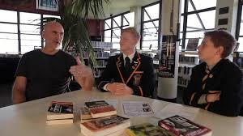
As a writer Phillip is best known for exploring themes including the relationship between boys and their fathers; questions of masculinity; issues of race; the impact of place on people and people on place.
Phillip who now lives in Bali is has recently completed the final instalment of The Debt, a six book high-octane thriller series.
The text in in this promotion is an edited selection from websites including the SMH http://tinyurl.com/ob3rksp and AUSTLIT: http://tinyurl.com/oj5acgk Edited by A. McLuckie 2014.

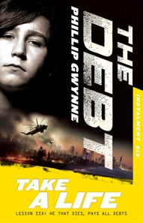
So, what might be the next challenge now Phillip has delivered the final instalment of The Debt?
''Being an expat in Bali, it just seems obvious that my next novel will be an adult novel set in Bali,'' he says. ''It's a no-brainer.''

