Lyndale College Library: Guest Speaker Program 2015
As part of the Lyndale Library Guest Speaker Program for 2015 we have lured a very special guest to commemorate ANZAC Day this year. Over the past two decades Mr Lambis Englezos AM, has made an outstanding contribution to historical and humanitarian research.
Lambis, a Greek born Australian Art teacher and historian, was responsible for discovering the mass war graves of Australian and British soldiers listed as missing after the disastrous WW1 Battle of Fromelles which took place between German and Allied forces on July 19, 1916.
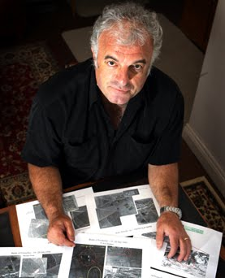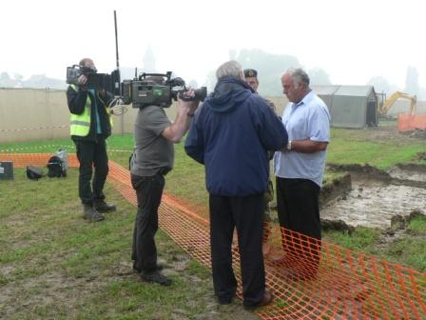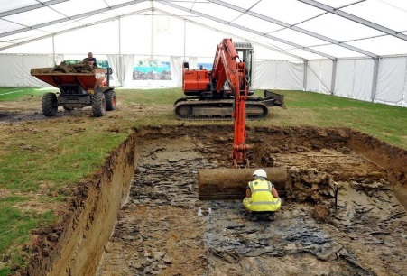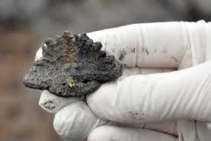
(Left) Lambis at work in his Melbourne home. (Above centre) the digging finally begins). (Far Right) A Rising Sun badge is recovered in the dig.
Today, thanks largely to the unflagging effort of Lambis Englezos, 250 Australian soldiers have been laid to a dignified rest in the new Pheasant Wood Cemetery, a facility designed and built to commemorate the ultimate sacrifice made by Australian Diggers in Fromelles almost a century ago.
In 2009 Lambis Englezos was appointed a Member of The Order of Australia, for ‘Service to the community through research and advocacy roles relating to Australian soldiers of the Great War buried in Fromelles, France’.
In 2013, the 25th Governor General of Australia Quentin Bryce paid public tribute to the great achievements of Lambis Englezos before presenting the inaugural Lambis Englezos Scholarship to a student at his alma mater Melbourne High School.
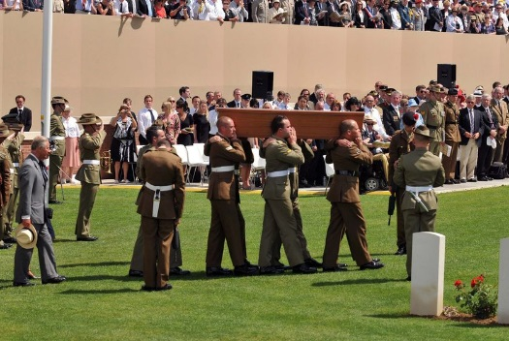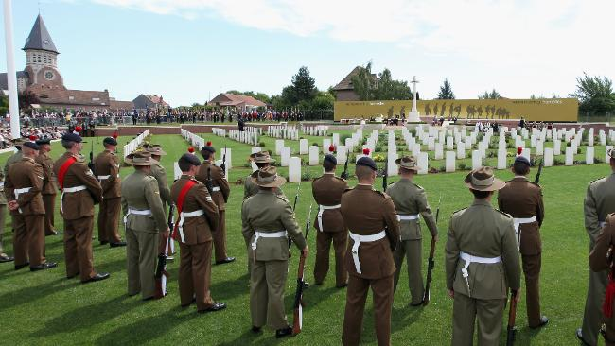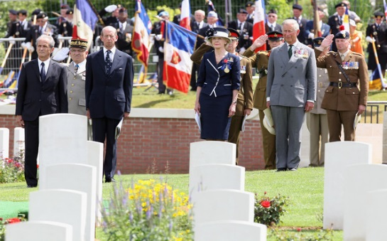
Fromelles (Pheasant Wood) Military Cemetery – Official Dedication Ceremony and Burial of the Last Unknown Soldier 19 July 2010, attended by the Prince of Wales, and the 25th Governor General of Australia, Quentin Bryce.
Lambis will be speaking in the Lyndale College Library on Friday 24th of April from 9am until 10am. Lambis will deliver 30 – 40min presentation + Q&A about the journey of finding the lost soldiers in France. His presentation is supported by images of lost soldiers, mass grave sites as well as images of soldiers whose families now know what happened to their men.
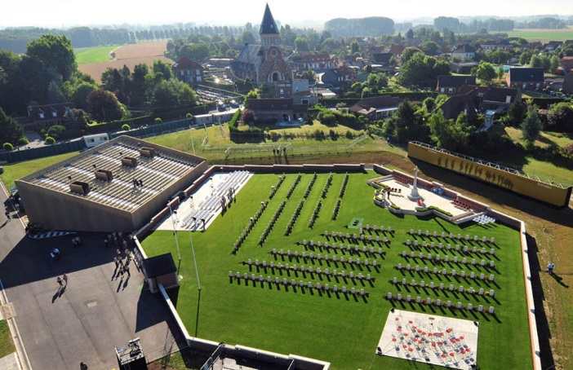 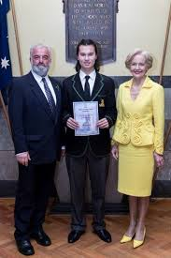 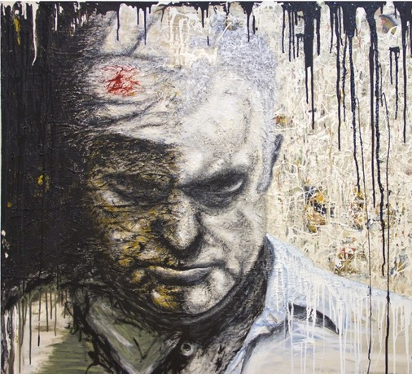
(Left) Aerial View of the new Pheasant Grove Cemetery: Fromelles. (Centre) Melbourne High student Aaron Zee, receives the first Lambis Englezos scholarship from Lambis and the 25th Governor General of Australia Quentin Bryce. (Far right) Lambis Englezos: Archibald Prize entry 2012 by George Petrous.
The images in this publication are ©. They are used solely for the promotion of an educational event and should not be reproduced for any other purpose. Compiled & Edited by A.McLuckie 2015.

