The Buzz  Edition 2 /June 2014 editor Andy McLuckie

**Our ongoing aim** is to make the Library a more comfortable, visually attractive and lively place for our staff and students to work and gather in.

With significant support from the Principal Class, we believe we have been able to substantially reinvent and redefine the library space so it now looks and functions more like a 21st century school library.

**Welcome to the June edition of *The Buzz***. This term the College Library has focused on two main aspects of a new operational agenda.

Firstly, as many of you will have noticed, the Library has embarked on a process of continual improvement and renewal of our facilities and services.

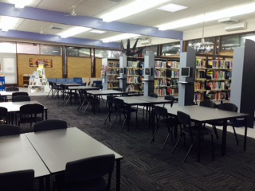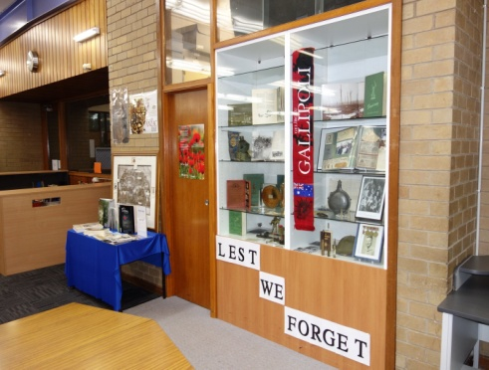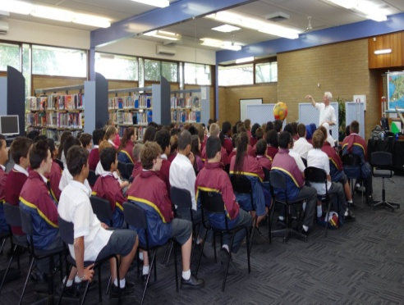

**In May,** we welcomed former Year 12 graduate Despina Karatzias back home to Lyndale for an update on her life and career after leaving the College in 1995.

**The College Library** has also put a substantial amount of effort into finding and securing high calibre speakers for our Guest Speaker Program which was launched at the start of this term.

In April, Jan Wositzky helped us commemorate **Anzac Day** with our year seven cohort.

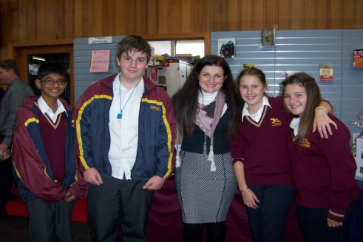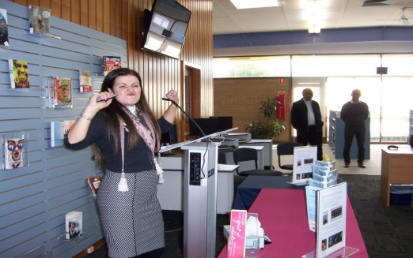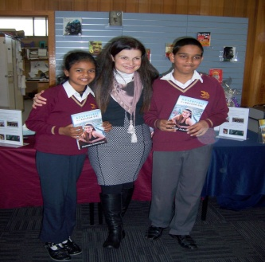

The Buzz  Edition 2 /June 2014

**Academy Award winning filmmaker** Adam Elliot also joined us in May, and had us in stitches with his stories about the road to Hollywood via Berwick where he was born, and Balaclava where Harvie Krumpet was made.

**A self confessed workaholic**, Adam left us in no doubt that success in any field is usually more about how much effort you put into your goals than how much natural ability you possess from the outset.

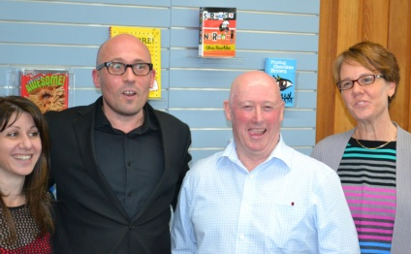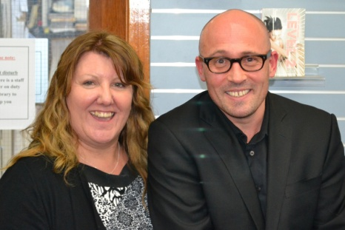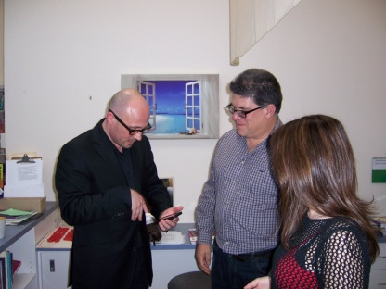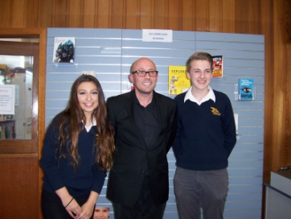

**Sam proved to be an inspiring speaker** and many of our students were very moved by the story of Sam’s struggle to recover physically and mentally after a terrible car accident on Australia Day, 1999.

**Around 400 staff and students** attended the Sam Riggio presentations in the College Library on June 12.

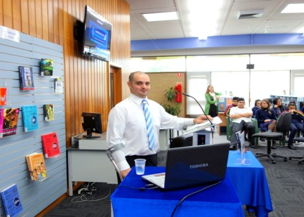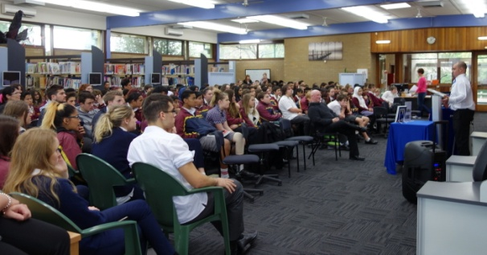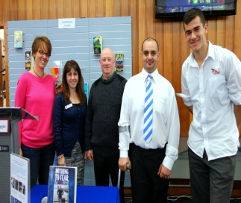

**A number of students stayed behind after each performance to meet Sam, shake his hand and pose for a photo.**

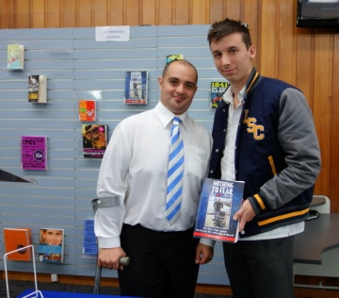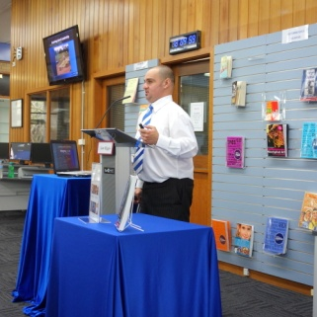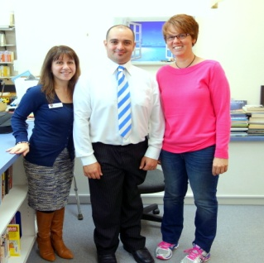

The Buzz  Edition 2 /June 2014

***Library Website Update***

Also keeping us busy is the development work we are doing on **the New Library Website**. We are currently adding the finishing touches to our working draft which we will publish early next term. The new website will offer staff and students a number of new features including the ability to access many of our resources remotely via the mobile network.

***Library Opening Hours***

Just a reminder – the Library is now open to students and staff at recess Mon-Fri. No passes are necessary for students.

 BUZZBIZ ... 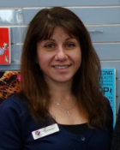 With Mary Koutras

**Guest speakers** continue to spark interest and excitement in our neck of the woods.

It’s wonderful to receive such positive feedback from staff and students regarding our first batch of presenters. A big thank you to staff for all the encouragement and support for the program thus far.

**And now a little housekeeping** to bring you up to date with some other recent activities in the College Library.

Congratulations to the winners of the following competitions:

**Anzac Day Poetry Competition - Micah Carganilla 9C**

**Mother’s Day Trivia Comp – Belquis Obura 9F**

**\*Staff Poetry Comp Winner – Robyn Stanton**

***\* Be sure to ask Robyn to recite a stanza or two when you next meet – ed.***

**Well it feels like Term 2** has just got started and we are already at the end of it! What a busy term it has been.

We have continued to improve the appearance and functionality of the Library by painting walls, adding new carpet, colourful prints, modern OPAC terminals, new roller blinds, table tops, new signage, display boards and attractive *New Books* display units.

**We have also installed** 2 large plasma televisions to aid our guest speakers and to keep our students up to date with all our latest promotions / activities / competitions / new books, etc.

**The fiction collection shelves** are bursting at the seams with new items. We continue to encourage students to tell us about new books that they would like us to acquire.

**Student feedback** is very important to us as it helps us to ‘fine tune’ the collection to support student needs and evolving interests.

 BUZZBIZ Cont...  With Mary Koutras

Finally, Term three looks set to be even busier for us with Book Week in the middle of August. Plans are already underway for some fun activities, competitions, and some **awesome guest authors – so stayed tuned!**

As you can see (above) Belquis is our carry over Trivia Champion. However, we hope to see as many students as possible enter our next Trivia Comp to see if they can steal the title away from the reigning champ. The competition theme will be announced soon.

Have a safe and happy end of term break and look forward to seeing you all in *your* Library real soon.

Regards from Mary.

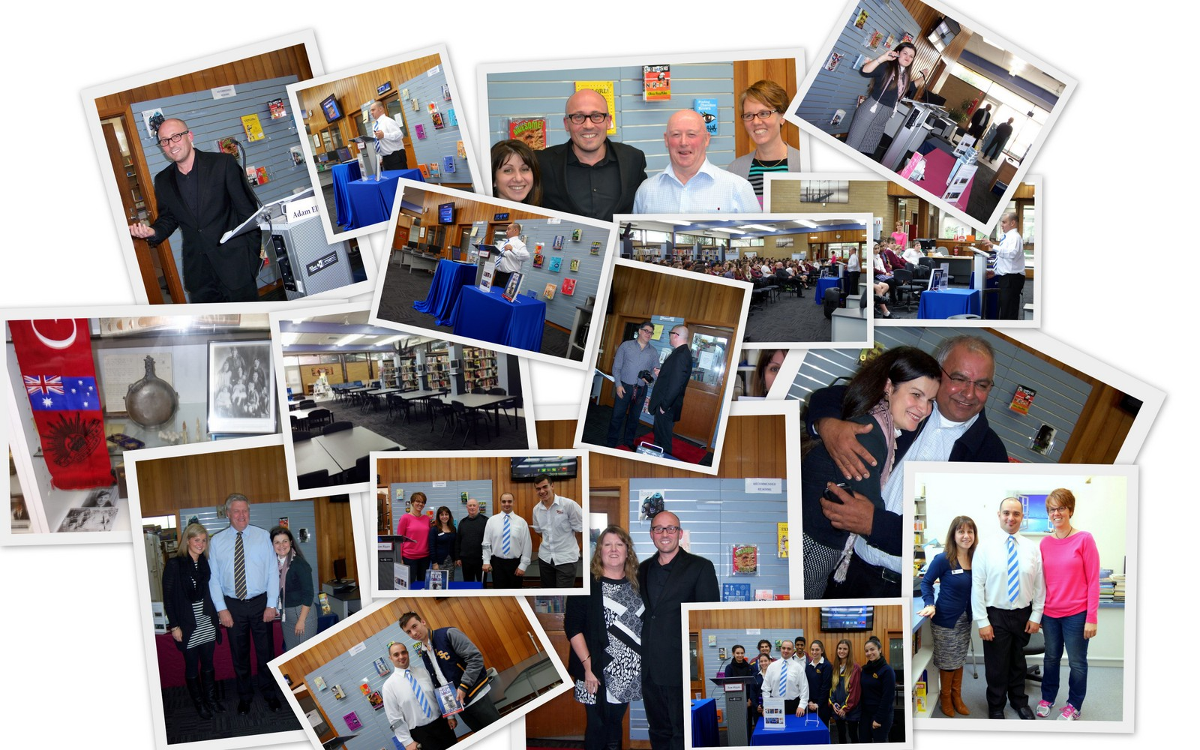

Edited By Andy McLuckie - 2014