*The Lyndale Library presents …*

**Scot Gardner** is an Australian writer known for his [young adult novels](https://en.wikipedia.org/wiki/Young_adult_novels). He has worked as a counsellor and [youth worker](https://en.wikipedia.org/wiki/Youth_worker) before becoming a full-time novelist.

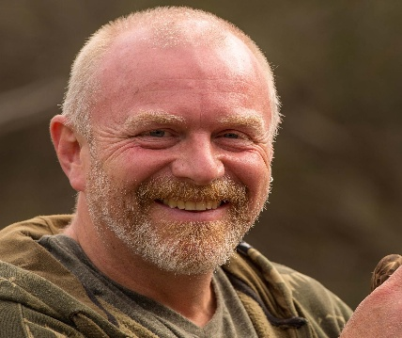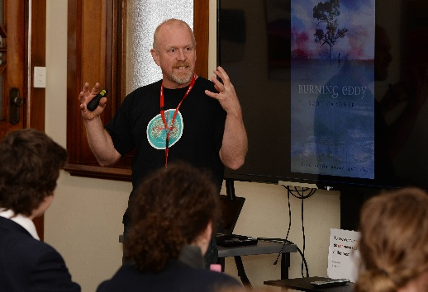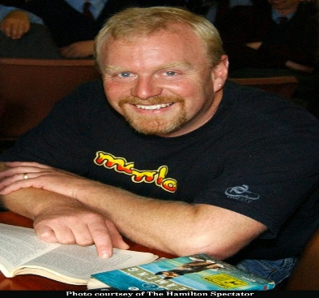

Scot was born in the Melbourne suburb of Greensborough and moved to the country with his family when he was twelve. His teenage years were spent in the Gippsland bush, where he still lives. Scot came to writing via counselling and youth work.

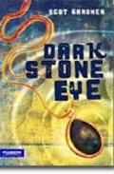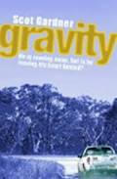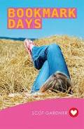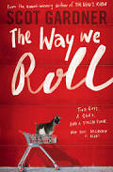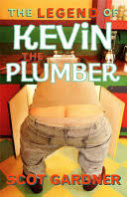

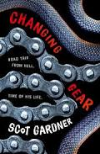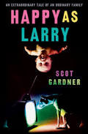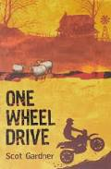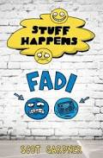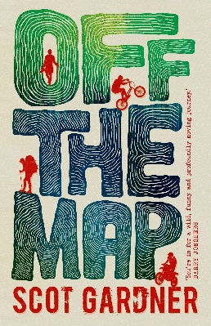

Scot’s books centre on the theme of growing up, especially the teenage years. Having worked extensively with disadvantaged teenagers Scot has some insight into the problems faced with high risk teenagers, especially young men and Aboriginal youths.

**Scot will be presenting to our Years 7-9 students on Friday 22nd August.**

**Lyndale Greens Primary grade 6s will also be joining us for this special presentation.**