For our second event for 2014, the College Library, on behalf of the school, is welcoming back a former Lyndale School Captain Despina Karatzias. Despina is a Year 12 Lyndale graduate from the class of ‘95.
Despina is coming to Lyndale on Tuesday, May 6 to talk to Lyndale students and staff about her:
- Lyndale school days and experiences as a young girl from a non-English speaking background
- The diversity of her life experiences post Lyndale
- Her quest to gain a foothold and make her mark in the tourist industry
- Her current role as a young business leader in the tourist industry
- The publication of her new book The adventures of a Balloon Girl
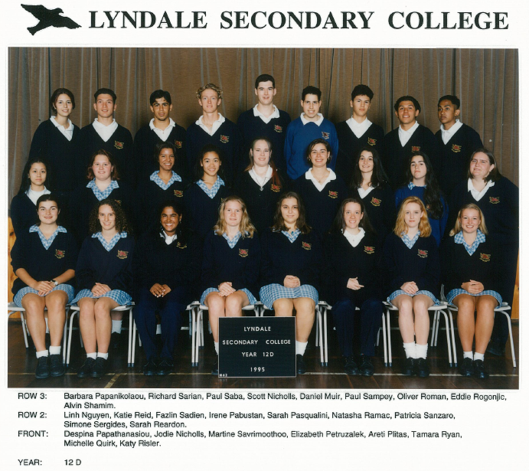
Please join us to welcome Despina, another Lyndale success story, by reserving your seats for Despina’s presentation which will take place at 2pm (during period 4) on Tuesday, May 6 in your College Library.
RSVP and all enquiries to Mary Koutras or Andy McLuckie

Note: If you would like to bring your class along please let us know well in advance of the presentation date.

A.McLuckie2014
Hey thrill seekers, why not book a flight!
Despina (Despi) Karatzias is manager at Global Ballooning. Despina joined as a sales consultant, 10 years ago.

