Lyndale College Library Guest Speaker Program Presents: Thomas King June 23rd 11.40am
Thomas King is a man on a mission. Minimising the degradation of the environment; ending world poverty; saving endangered species from extinction and preventing cruelty to animals are just some of the things on this young man’s mind. Thomas traces the development of his social conscience back to the time he chanced upon a documentary on Orangutans while channel surfing on TV. He was 13 years age.
“It was footage of a dying orangutan, dragging its malnourished body through a scene of endless forest destruction. I proceeded to listen-in, only to discover that the reason for this abuse and destruction lies in over 50% of household products - an ingredient called Palm Oil”.
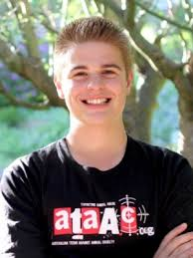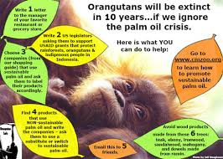
Thomas’s heartfelt response to the documentary was to start up the Say No to Palm Oil website to raise awareness of the ways in which palm oil production contributes to deforestation, animal cruelty, and human rights violations in countries including Africa, Southeast Asia, Borneo and Brazil The website has developed significantly since it was first created and now receives half a million visitors annually from over 180 countries. http://www.saynotopalmoil.com/
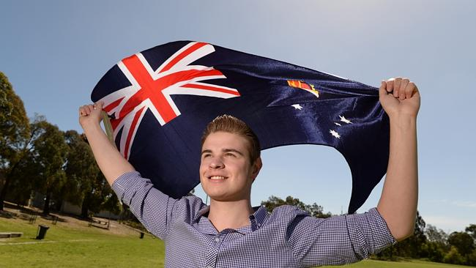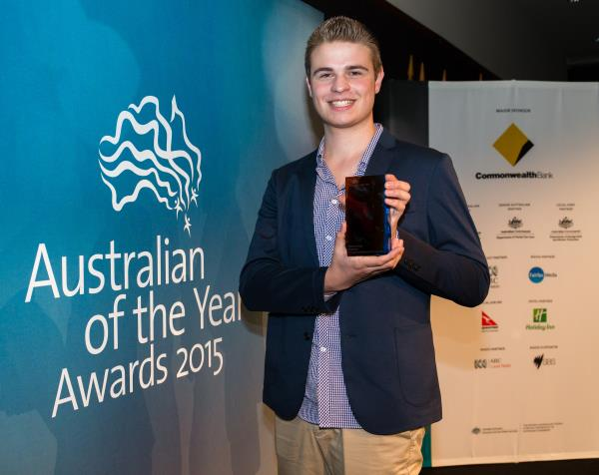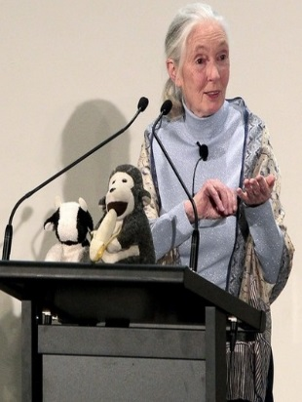
For the past 5 years, Thomas now 18, has brought his trademark energy and enthusiasm to an increasing number of roles and undertakings. Thomas has worked with a range of environmental, animal rights and humanitarian focused organisations including the Jane Goodall Institute, ATAAC (Australian Teens against Animal Cruelty) and the youth division of the United Nations. During this period Thomas has accumulated a number of well-deserved accolades including VCE Leader of the Year, Victorian Young Australian of the Year and Youth Advocate of the Year for Zoos Victoria's Fighting Extinction program.
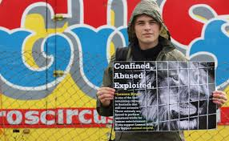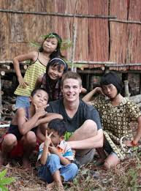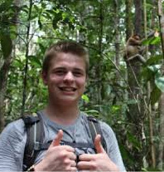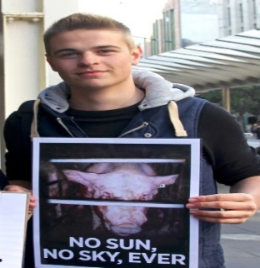
Thomas is currently Operations Manager at ATAAC. (Australian Teens against Animal Cruelty) .Thomas is also in high demand on the guest speaker circuit and recently had the honour of being selected as keynote speaker at the Jane Goodall Youth Summit for 2014. Travel continues to inform Thomas’s view of the challenges ahead for the earth’s flora, fauna and human inhabitants, but his belief in the ‘power of one’ is a strong as ever: “There is this idea that as an individual we can’t really do much to help solve problems - I would argue otherwise. Remember it only takes 10 complaints about the same topic for a large corporation to sit down and have a meeting about it. Each of us has the power to create a profound impact”
The informational content in this promotion is derived from the following online sources: http://www.saynotopalmoil.com/ http://ataac.org/team/218-thomas-king-operations-manager.html http://sustainability.ceres.org.au/project/what-inspires-me-thomas-king/ Pictorial content used in this promotion are for the promotion of a single non-profit school based educational event. Compiled and edited by Andy McLuckie, 2015.

