GSP #2: Our second guest speaker for 2015 is Mr Abdi Aden. Abdi’s presentation (2 sessions) will take place in the College Library on Tuesday May 26 during periods 1 & 2.
Abdi Aden was born in Somalia. He grew up in Mogadishu until the outbreak of civil war in 1991 destroyed his home and separated him from his family. Effectively an orphan at the age of 12, Abdi fled to Kenya with a small group of survivors. On the way they were hunted by Somali death squads and on a daily basis suffered from the effects of exposure and starvation. As Abdi puts it: “I remember feeling petrified. “I thought my heart would stop when we were going from Somalia to Kenya…I said to myself that if I ever make it, I’m going to be the best person and I’m going to appreciate everything”. After 3 months on the road Abdi and the group arrived in Kenya. Of the 312 that set out, only 5 survived the journey.
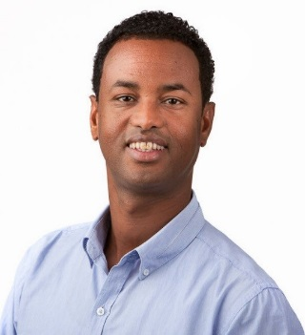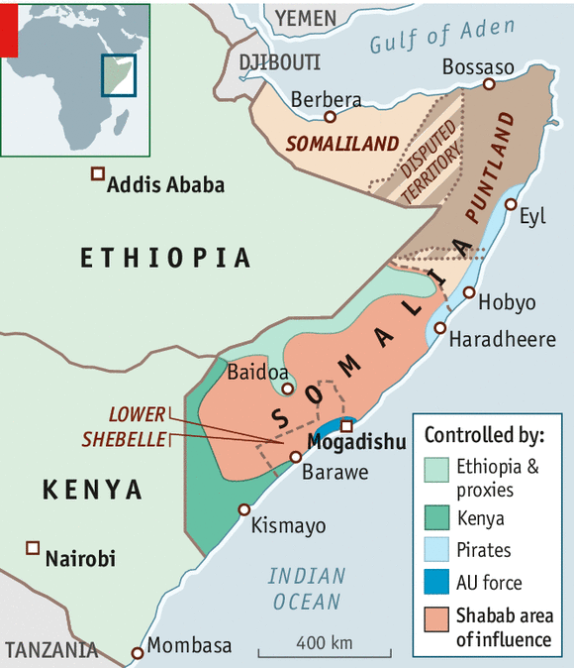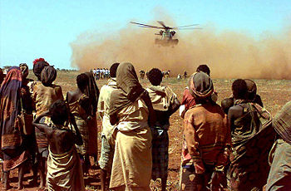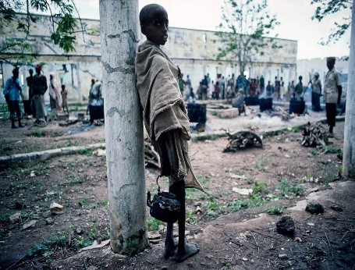
Eventually Abdi made his way back to Mogadishu to search for his family – he didn’t know if they were dead or alive at this stage and as it turned he would not be reunited with his mother until his late teens. The next few years saw Abdi alone and drifting. He lived with gypsies in Romania, until a people smuggler at the Somalian embassy helped him get to Germany. In Germany he obtained fake papers which gained him entry to Australia at 15 years of age. Broke, homeless and unable to speak English, Abdi wandered the Melbourne streets sleeping in churches and mosques. One lunchtime he was bashed by 3 strangers in the Melbourne CBD.
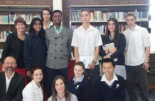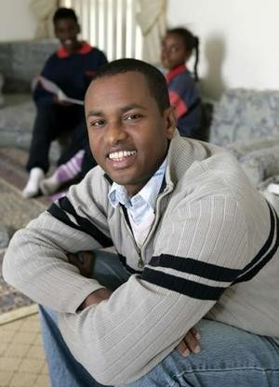
1996
And yet against the odds Abdi not only survived he went on to thrive as opportunities gradually came his way. Abdi completed his secondary education and went on to Victoria University to complete his studies as a Youth Worker - a profession that to this day allows him the opportunity to be proactive in issues of social justice and community development. Abdi has his own family now and as an Australian citizen continues to contribute to the ongoing debate over refugees seeking asylum in Australia. Abdi has been active in the media for some time. His stories and interviews with him have been have been published in The Age and The Australian newspapers. In 2006 Abdi partnering with Hume Shire Council started homework programs for refugee Somali children struggling with their studies. In 2007 Abdi received a Victorian Refugee Recognition Award for his humanitarian work with Melbourne youth.
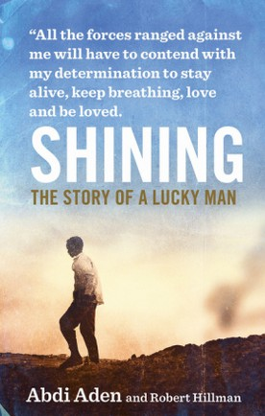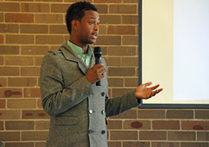
In 2012, Abdi appeared in the SBS documentary series Go Back to Where You Came From. More recently Abdi was active promoting the Vic Health report on what to do as a bystander witnessing racism. Currently Abdi is splitting his time between his youth work and public speaking. His new memoir – Shining: Story of a Lucky Man (Harper Collins) will be available in June 2015.

Images used on this page are solely for the promotion of a single, non-profit educational event at Lyndale Secondary College. Edited by A. McLuckie, 2015.

