The Buzz Edition no: 3 2014 edited by Andy McLuckie
Welcome to the Term 3 edition of The Buzz. Well, most of this current term has passed in a blur for Library staff. Like the rest of you, we have been very busy, but we have also had many enjoyable and memorable moments as well.
Thank you to all the staff and students who participated in all the quizzes and competitions we ran during the term. The match the teacher to the book competition during Book Week was a particular success and we were amazed to discover how many avid readers we have in our midst.
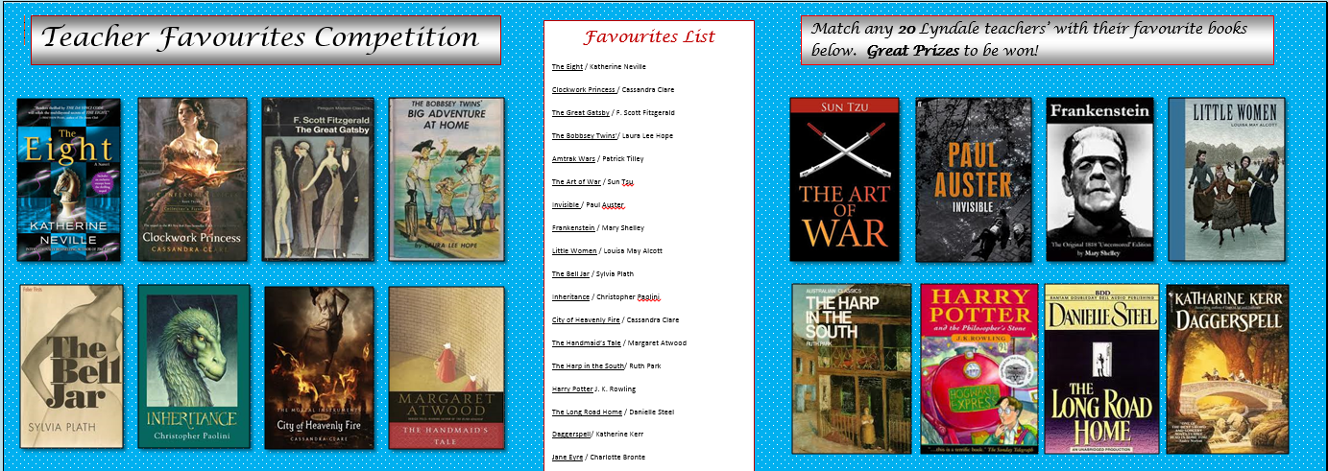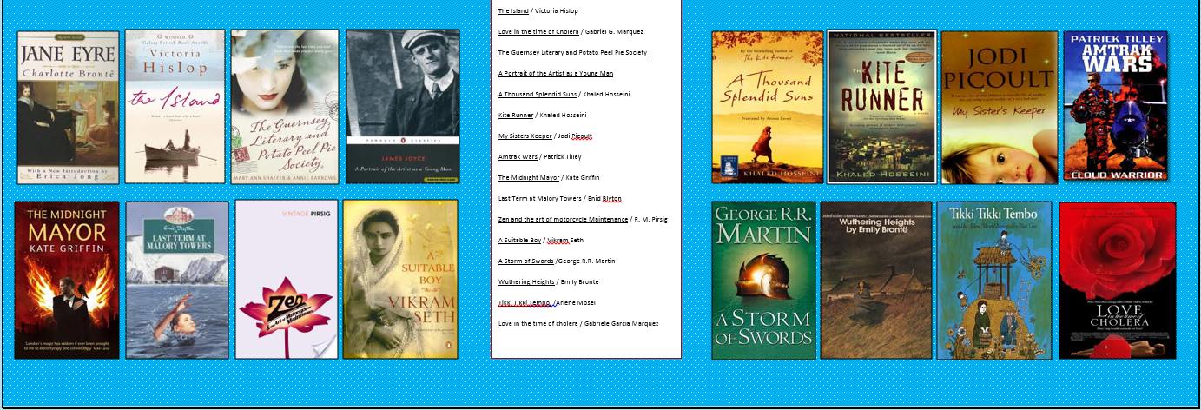

Many staff members happily came out of the woodwork and shared their favourite books with the school community. This competition turned out to be a very effective way of communicating our appreciation of the joys and benefits of reading to our students and to each other. (See Mary’s Buzz Biz for prize winner details).

A great deal of effort also went into the Guest Speaker Program during this term. The organisational work is certainly an ongoing challenge but we wholeheartedly believe that the benefits of the program are demonstrably clear even in our inaugural year. In Book Week alone over 700 students turned out to see our guest authors and the total for the year (after Brad Ottens on 18/9) will be around 2300 students, twice the population of the school.
Of course ‘bottoms on seats’ statistics only tell part of the story, the real evidence of the success of the program to date has come from the warm and encouraging feedback from Lyndale staff and many of our students. Library staff do not take this support for granted. Without the backing of the principal class and all the teachers who see the merit in our efforts and help us in too many ways to mention here the program could not be sustained. Happily we see it going from strength to strength in 2015.
The Buzz September, Edition no: 3 2014.

The Guest Speaker Program: During Book Week 2014 we were fortunate to have 3 highly successful guest authors at Lyndale Library. Archie Fusillo, Phillip Gwynne and Alice Pung spoke to our students about the importance of reading as a means of expanding our knowledge and consciousness of the world we live in and as a means of connecting with others through the ongoing transmission of individual stories.

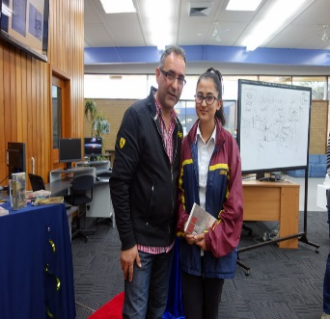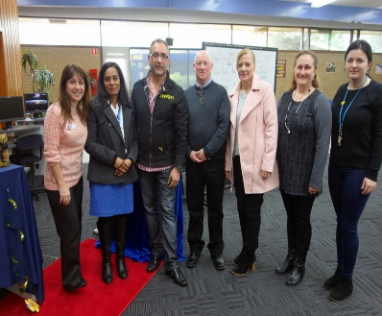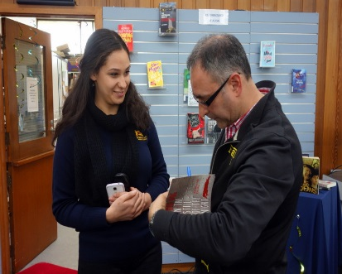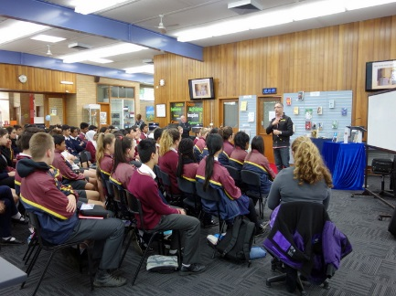
Author Archie Fusillo meeting staff/ students and signing books

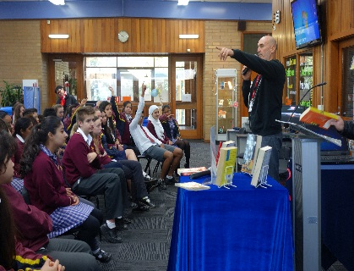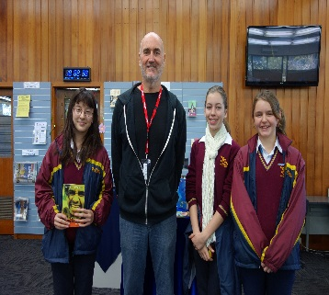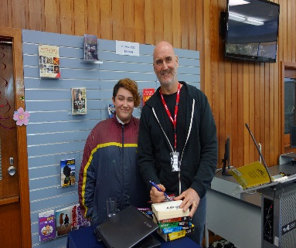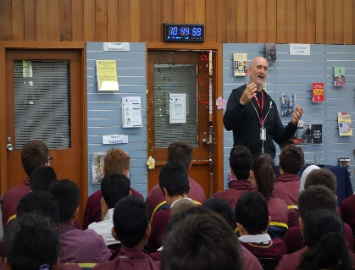
Phillip Gwynne entertaining the troops and posing with students. A number of our students won signed copies of Phil’s books for asking the best questions of the morning.
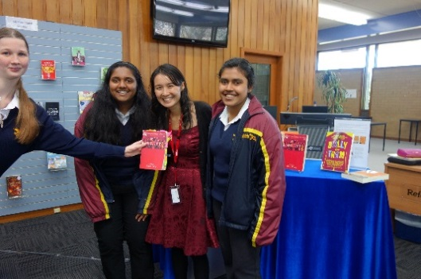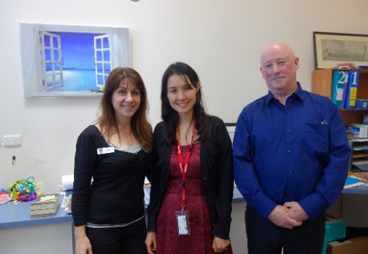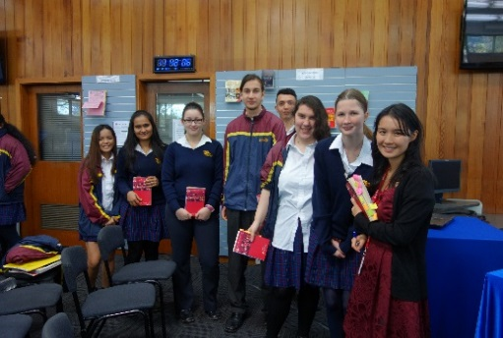
Author Alice Pung with some of her many fans.
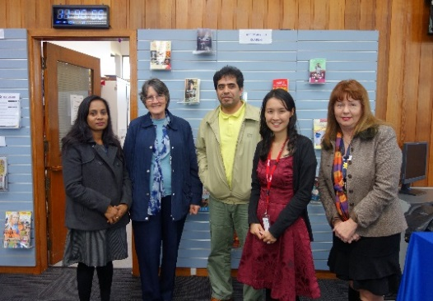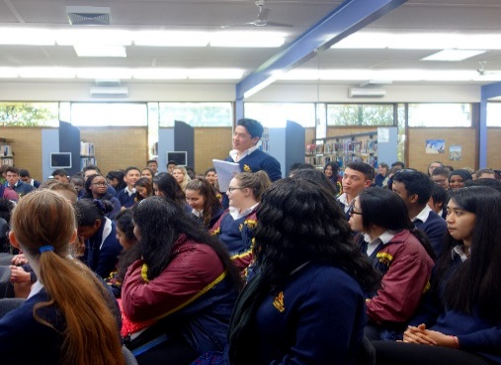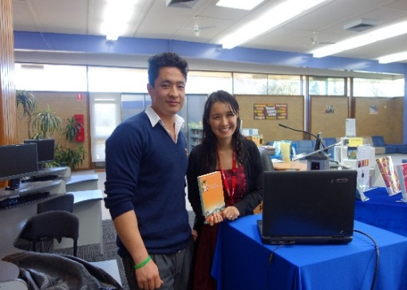

The Buzz September, Edition no: 3 2014.

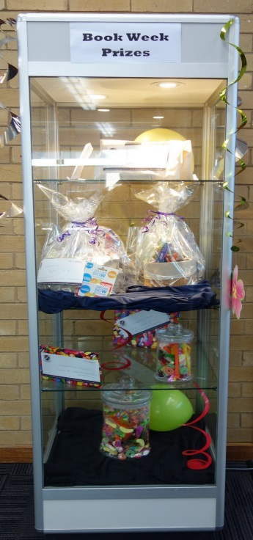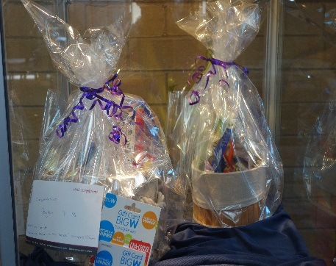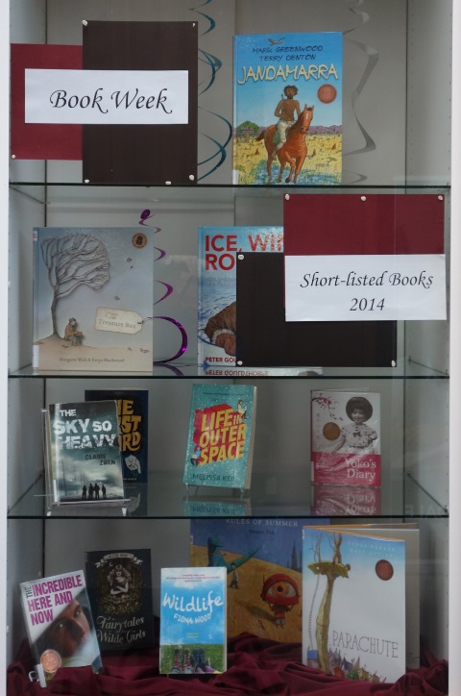
Some of the many Book Week prizes and Shortlisted Books on display during Book Week 2014.

Our final guest for the term 3 will be Geelong AFL legend Brad Ottens. Lyndale staff and students will be encouraged to turn up in club colours and welcome Brad to our school on Thursday 18 September.

HeyFans!
All Australian 2001
Mark of the Year 2006
Premierships: 2007, 2009, 2011
_____________________________________________________________________________________
Brad Ottens: Born 25 Jan 1980
Height: 202 cm Weight: 108 kg
Senior clubs: Richmond, Geelong
Games 245 Goals 261

*Brad Ottens, three time AFL premiership player will be speaking in the Lyndale College Library on Sept 18, 2014*
Be There!
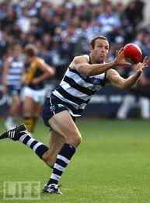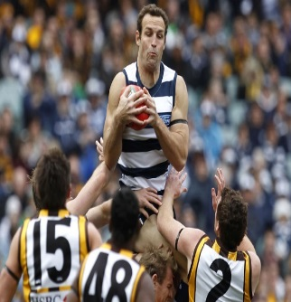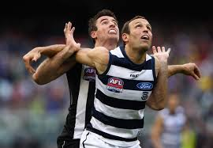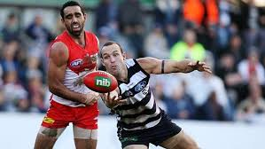
BuzZBIZ with MARY

Greetings to all Lyndale students, staff, parents and friends….
Another term is ending and soon the Xmas trees will be on display in the shop windows.
What a fantastic term 3 it has been with the library’s main focus for the term being BOOK WEEK (August 18-22).
We worked hard to lure three superb guest speakers to our library during Book Week to entertain all year levels.
Kicking off the week we were fortunate to have Archie Fusillo, author of Bruises, The Dons and his latest work Dead dog in the still of the night. Archie a former school teacher had his audience captivated from the minute he was introduced. Archie’s two sessions entertained over 300 students and his stories brought a flood of emotions to students and staff listening and learning about his Italian upbringing in inner Melbourne during the 70s. Frequent bouts of laughter and even a few tears were shed while listening to Archie talk about his father, his grandmother, his life in Fitzroy in the 70s and the importance of learning to read, write, communicate and connect with family and friends.
Phillip Gwynne, author of Deadly Unna? was our next guest. Phillip grew up in Adelaide and had no interest in reading as a young boy. Playing Aussie Rules football was his only real passion. All this changed when one of his teacher’s recognised his imaginative potential and convinced him to start writing stories of his own. Phillip had a few false starts along the way to discovering his true vocation. He tried his luck at computer programming and marine biology before discovering that his true love was… writing!
Although a professional writer Phillip came across as a plain speaker and his message was simple. He told our students that as a boy he was a below average student from a large working class family. He shared a small room with three brothers and his alcoholic father was prone to frequent outbursts of unprovoked violence.
And then one day a teacher helped him discover another world - the world of books. Reading was a means escape from his troubled home life and a way for Phillip to connect with the wider world – the central theme of Book Week this year. Phillip concluded his talk with the message that (given the opportunity) it’s never too late to turn your life around and begin to discover your full potential.
Alice Pung joined us during Literacy week. Our year 11 students who are currently reading “Growing up Asian in Australia” (edited by Alice) could not believe she was here at their school in the flesh! They thoroughly enjoyed listening to Alice’s experience of growing up with immigrant parents and how she was able to rise above the racist barbs sometimes directed at her, her family and her friends. Instead Alice focused on her studies and went on to complete a Law Degree at The University of Melbourne.

On a more light-hearted note Book Week also provided our students with the opportunity to win some great prizes. Congratulations to Connor Robins (year 10) for winning both the crossword puzzle and the trivia competitions. Well done to Ardeshir Sahmeddini and Radovan Micic (year 11) for guessing closest for the lolly jar competitions and a big congratulations to our year 8 girls, Peyton Coghlan-Savage and Stephanie Syrios for making a fantastic effort to match the teacher to the book competition. Both girls won a hamper filled with goodies. (See pics above)
The winner of the CBCA short-listed book of the year for older readers is Wildlife by Fiona Wood. The library has all books that were short-listed for 2014, so we encourage all our students to come in and borrow these wonderful, nominated books.
Finishing off term 3, we are excited to have former AFL superstar Brad Ottens as our guest speaker on 18th September. Brad played an important part in Geelong’s 3 premierships. 2007, 2009, 2011. Brad will be presenting in the College Library on Thursday 18th September. Amongst other things he will be speaking to all year levels about the importance of resilience, self-discipline and sheer hard work as the essential keys to success in any chosen field.
Finally, thanks to all the staff and students who have commented favourably on all the new books that have been added to the collection so far this year. We were able to attend a couple of big discount book sales this year where we bagged heaps of great new titles - many of them at bargain prices. The shelves are currently brimming with great new reads for students of all ages.
We hope to come back refreshed and excited for the commencement of term 4. During the final term we will start planning for the 2015 year. We have ideas and plans already underway and as always we will do our best to make your visit to our Library a pleasant and happy one.

Happy Holidays!! Mary.

