The Buzz Edition no: 6, June 2015 edited by Andy McLuckie

Welcome to the second edition of The Buzz for 2015. It’s been another busy term with plenty of competitions and Guest Speaker events and number of improvements to the library particularly in the designated reading area. (See Mary’s Buzz Biz for pics and details).
In the weeks leading up to ANZAC Day the library ran its annual ANZAC Poetry Competition. The entries this year were of very high standard and the judges had real difficulty determining the winners. In the end first prize was awarded to Kylie Lin of 8C for her thought provoking and beautifully written piece entitled Endurance. Kylie’s prize was a Village Cinemas movie pack for two adults. Below is an extract from the poem. The poem is printed in full on the last page of this page of this edition of The Buzz.
Endurance
Young and aged males exchange tears and words of hope to family -Which could be their last
With a racing heart of honour and pride and heads held high
No soul alert and mindful of the bloodshed
They will need to endure
Kylie Lin 8C
Tristan Rios (11G) took out second prize and Caroline Porublev (11F) and Phoebe Oliver (8C) tied for third place. Congratulations to Tristan, Caroline and Phoebe, all of whom received book prizes and thankyou also to all the other students who entered - your contributions were uniformly excellent so keep up the inspiring work.
As part of our efforts to commemorate the centenary of the Gallipoli landings the library was particularly pleased to welcome Mr Lambis Englezos to the College to talk about his role in discovering the mass war graves of Australian and British soldiers listed as missing after the Battle of Fromelles on the western front in 1916.
Lambis was a warm, friendly and articulate speaker who peppered his compelling narrative with a number of moving and humorous anecdotes. Students and staff were clearly impressed by Lambis’s presentation as well as the outstanding contribution he has made to historical and humanitarian research thus far. A number of students stayed behind after the presentations to ask questions and have their photo taken with Lambis. Casey Neill of the Dandenong Journal wrote about the presentation in the article below.

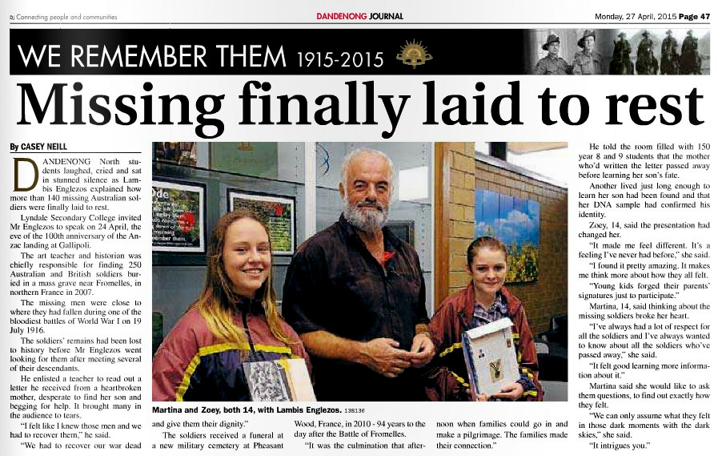Above: Presenter Lambis Englezos with Martina and Zoey in the College Library

The Buzz Edition no: 6, June 2015 edited by Andy McLuckie

Our second presenter in the Library Guest Speaker Program for 2015 was Somalian born youth worker and human rights advocate Mr Abdi Aden. Abdi spoke to our students in the last week of May about his perilous journey to Australia after his home in Mogadishu was destroyed and a number of his family were killed in the disastrous and ongoing Somalian Civil War. Students were moved by the tragic circumstances that led him to flee his homeland but they were also heartened by the great success Abdi has made of his life since arriving in Australia alone and destitute at the tender age of 15. Georgia Westgarth covered Abdi’s presentation for the Journal and her article appears on page 5 of this edition of The Buzz.
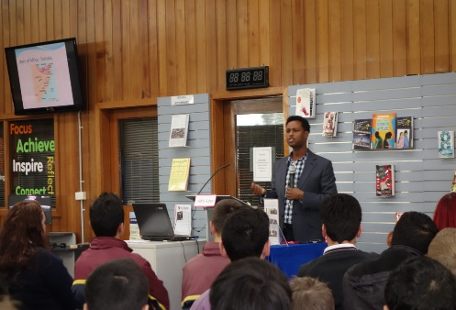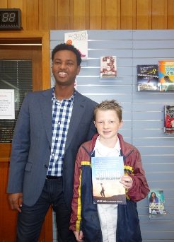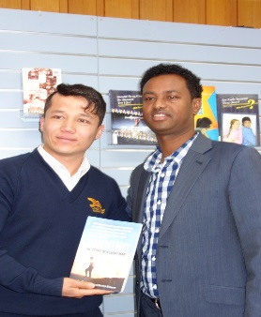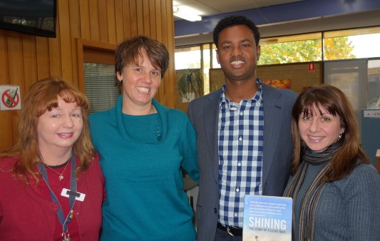
Abdi Aden presenting in the College Library, May 26.
Coming up…23/6
We are pleased and excited to announce that our next speaker will be the 2015 Victorian Young Australian of the Year – Mr Thomas King. Amongst other things Thomas will be speaking about his work as an environmentalist, film maker and journalist. Thomas, now 18, received his 2015 Victorian Young of the Year award in recognition of the great work he has done to end the unsustainable production of palm oil in S.E Asia and also for his efforts to save the Orangutans of Borneo and Sumatra from imminent extinction.

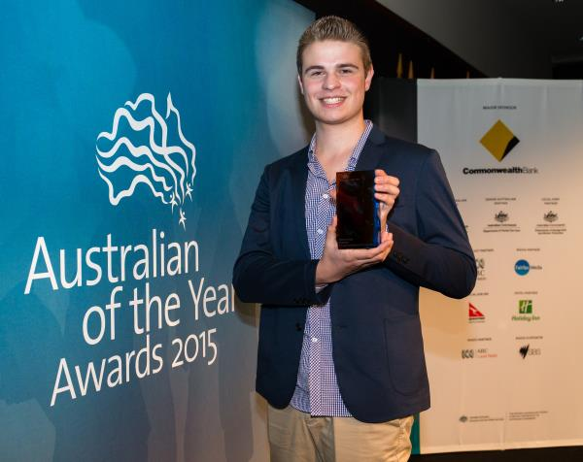

By telling his story Thomas will aim to inspire our students to think about what it means to be a good global citizen in the 21st century. His own achievements are a testimony to the good that can be achieved by one thoughtful and dedicated individual. All our students are encouraged to come along and see and hear this outstanding young Australian in action at 11.40am on the 23rd of June.

Email bookings via Mary Koutras or Andy McLuckie are essential. For more information on the Guest Speaker Program and our presenters past present and future see: the What’s On page on the library website @ www.lyndallibrary.org

BuzZBIZ… with MARY

Hi to all The Buzz readers out there. In this edition of Buzz Biz I want to talk a bit about further improvements that have been made to the Library as a space as well as improvements we have made to the collection of learning resources overall. I will also report on how those improvements have contributed to the perception of the library as a useful learning resource as well as a comfortable and safe place for students to read, study, or meet up with like-minded friends before and after school as well as during recess and lunchtimes.
The new reading area: Judging by the popularity of this area within the library I would say the students are happy with the changes that have been made. The most obvious addition to the space is the new made to measure display unit which now houses and displays all the latest magazines, journals and newspapers. The Picture Book Collection has also been relocated to the new display unit so our students and teachers can see the diverse range of items available to them. Age appropriate picture books are a wonderful adjunct to conventional reading texts and in my experience students love the way they can jump straight into a story without reading large slabs of text to come to grips with the substance of a story.
The Senior Fiction Collection: This new collection continues to expand. A number of students and staff have offered suggestions for this genre collection which was developed to cater for senior reading tastes and also for staff who love kicking back with a good novel or two during term break.
Graphic Novels Collection: The students are also loving the many new additions to the Graphic Novels Collection – this genre collection is drawing in students who won’t as a rule go near regular books so we count this as a small but significant breakthrough with students who otherwise do not read.
Easy Reads: For a variety of understandable reasons some of our students do struggle with the written word in English so we are also developing our Easy Reads Collection as yet another means of engaging students in reading and literacy building activities. The easy reads items will be shelved by genre only so they can be found quickly by our students.
All three collections Senior Fiction, Graphic Novels and Easy reads are located facing the designated reading area.
Student numbers: Library Recess and Lunchtimes
I’m happy to say that during recess and lunchtime our Library is now more often than not filled with students involved in productive activities including reading, group work and private study. The designated reading area with the comfy chairs is often full of students taking a break from their studies to peruse the newspapers as well as magazines on a wide range of subjects including fashion, health, cars and current affairs. We believe student numbers in the library (outside classroom hours) are growing for two main reasons. Firstly, students are developing the view that the Library is a repository of knowledge resources that are useful and relevant to their studies and recreational pursuits. Secondly the library is a place where things ‘happen’. This year seven great guest speakers will present in the library through the course of the year following in the footsteps of the seven great guests from the previous year. We are also be running a number of regular competitions and events that encourage students to participate in fun ways that improve their minds and their understanding of the world they live in. Student involvement in library programs, competitions and events are always acknowledged in some way either through displays of their work in the library; via the local press or through publications such as The Buzz and/or the school newsletter The Falcon. We also give out great prizes!
Increasing levels of student participation and interaction with their College Library is slowly but surely becoming the norm for an increasing number of our students. Students clearly feel relaxed and comfortable within the space; they are certainly asking us more questions and learning how get the most out of the resources available to them.
Homework Club Update:
Home Club students now have a dedicated space within the Library for their club get-togethers on Tues and Wed (3:10-4:00pm). To get the most out of these sessions all students are required to sit with their designated tutor in the space that has been allocated. Apart from ensuring that students who are members of the club are all engaged in some kind of productive work the tutor is better able to monitor student movements if the club are seated as a group. For accountability and duty of care reasons students who sign on for Homework Club cannot leave until 4.00pm without notifying their tutor for the session.
Well the page is full already, so that’s all from me for this edition - hope to see you in the College Library soon – Mary.
The New Reading Area in the College Library 2015

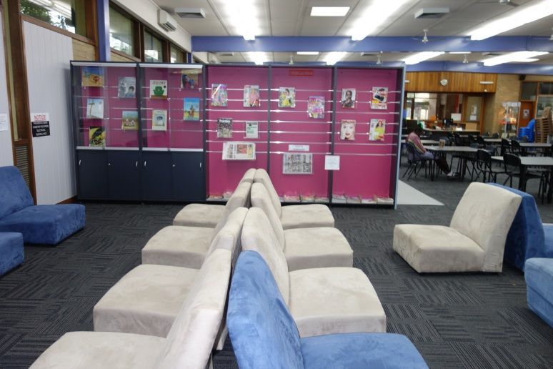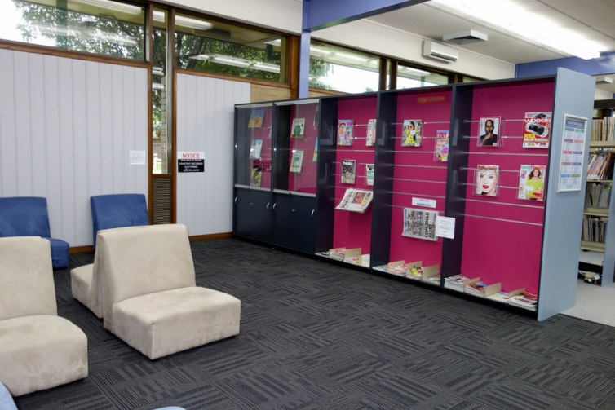

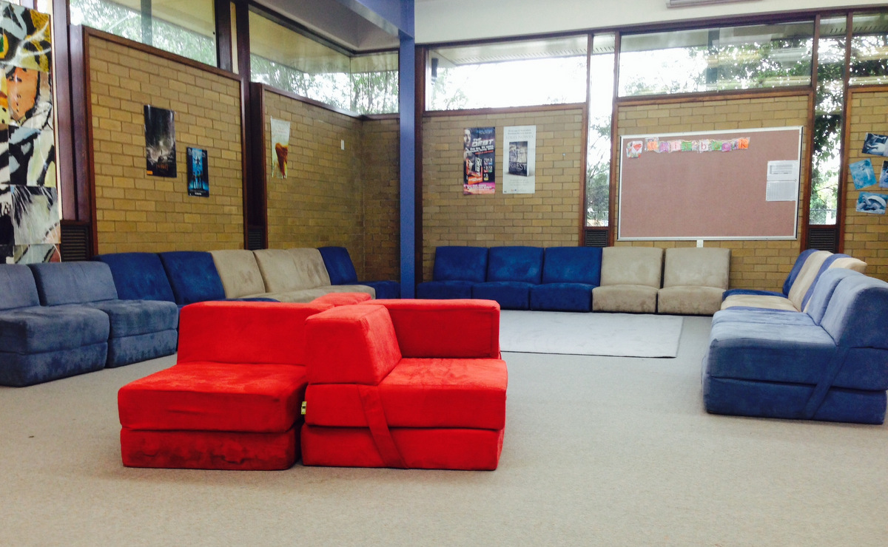
Above centre: The old Reading Area – 2014 Yuk!
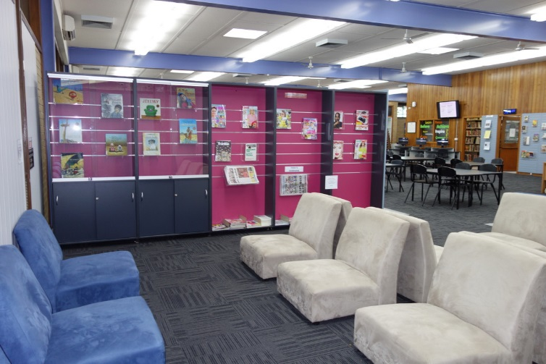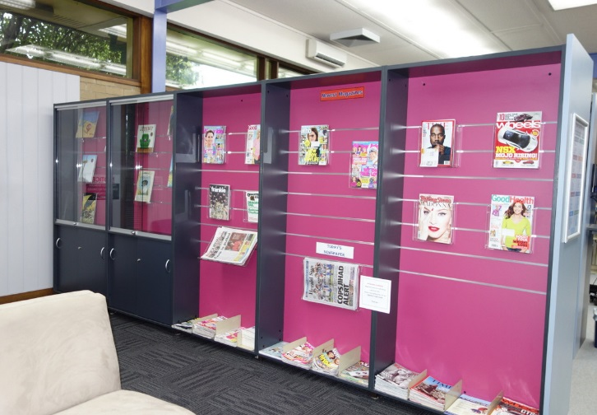
The Buzz Edition no: 6, June 2015 edited by Andy McLuckie

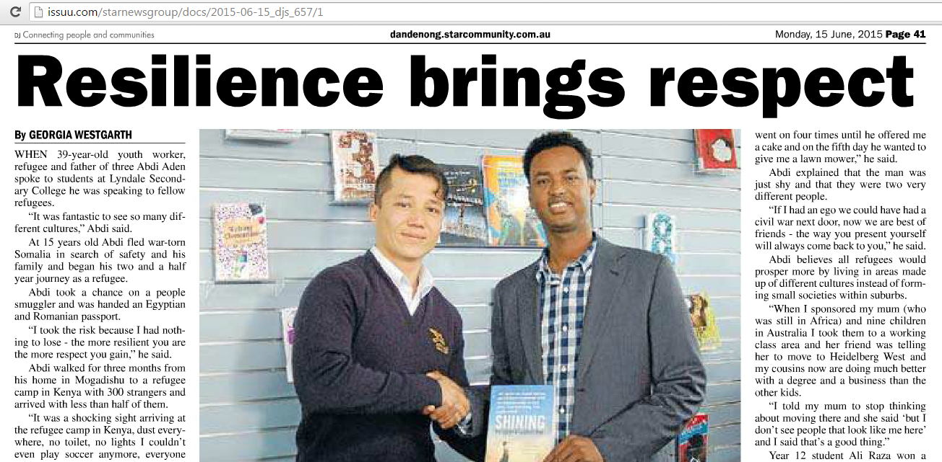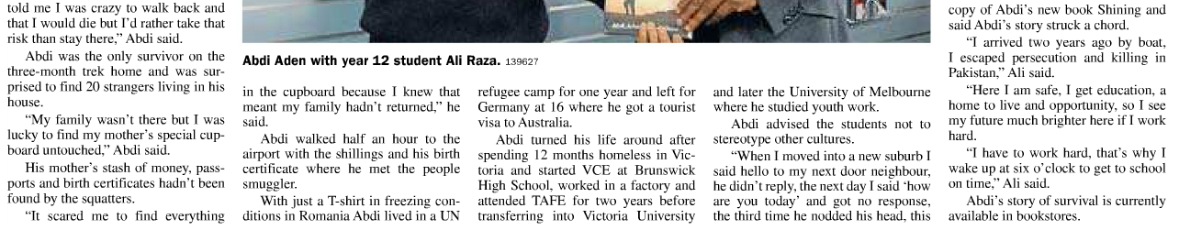
Abdi Aden in the Lyndale College Library with Ali Raza one of the book prize winner’s.

Endurance

Young and aged males exchange tears and words of hope to family, which could be their last
With a racing heart of honour and pride and heads held high
No soul alert and mindful of the bloodshed
They will need to endure.

The soaring heat,
Torrents of thrashing rain,
Bone-chilling winds.
They endured.

The real agonising torture of one’s honour, laying in the twisted paths ahead
The raging anger of gunshots,
Deafening cries of shells, deep muddy, muggy, trenches.
Some endured.

Ahead… No man’s Land.
Piled with lifeless bodies of friends and foes, a blood bath
The graveyard of the dead, slain, and dying…unburied bodies swarming with flies.
Some endured.

Of those whom endured
Their lives were seen from a different perspective
Mental physical casualties were taken.
Scarring the weak, and scratching the strong.
Though it is someone else’s story,
One will forever honour, commemorate and remember,
All of the sacrifices made for our benefit…
On ANZAC Day.

Kylie Lin 8C, 2015.

