Lyndale College Library Guest Speaker Program Presents: Lauren Burns, OAM.
We are very pleased to announce that our fourth Guest Speaker for 2015 is Olympic Gold medallist Lauren Burns, OAM. Lauren won Australia’s first ever Gold medal in Taekwondo at the 2000 Sydney Olympics. Lauren will be speaking in the College Library on Friday, July 31st between 11.45am -12.45pm. (Period 3)
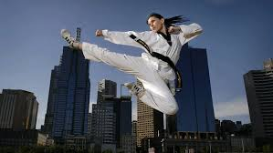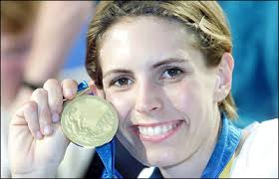
The Melbourne born daughter of singer Ronnie Burns and dancer Maggie Burns (nee Stewart) Lauren got involved in Taekwondo as a consequence of her brother’s interest in the show Teenage Mutant Ninja Turtles. Encouraged by her brother and father (who both took up the sport themselves) Lauren started training at 14 and began competing at 16 years of age.
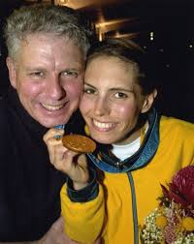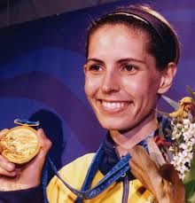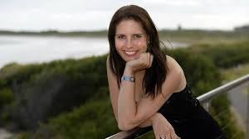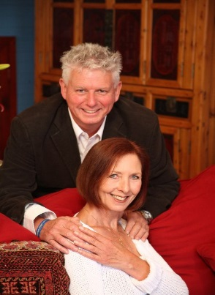
After her gold medal win in the under-49kg taekwondo event, Lauren immediately announced her retirement from the sport. Years of rigorous training and ‘living on salads’ made Lauren yearn for the things she had denied herself over the years. To celebrate her gold medal win Lauren had only one request: “I just want pizza and beer,” Burns recalled.
In the years following her win, Lauren completed a Bachelor of Science Degree and has remained busy and productive. Now the mother of two girls and the recipient of an Order of Australia Medal, Lauren participated as a commentator at the Athens and Beijing and Olympics; wrote her autobiography Fighting Spirit and more recently published a cook book: Food from a Loving home. Lauren has remained in high demand as a guest speaker and has spoken to over 200,000 people since the Sydney Olympics.
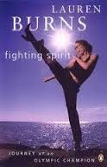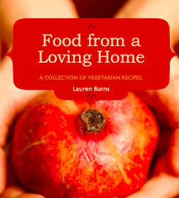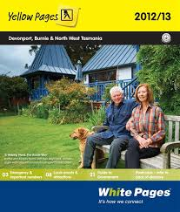
Apart from practising as a naturopath in the inner Melbourne suburb of Northcote, Lauren also finds time to serve as a director of the Appin’s Hall Children’s Foundation (founded by her parents), and through the organisation known as Red Dust Role Models Lauren is involved in delivering healthy lifestyle programs to indigenous communities around Australia.
The informational content in this promotion is derived from the following online sources: http://www.laurenburns.com/ , The Australian and http://en.wikipedia.org/wiki/Lauren_Burns Pictorial content used in this promotion are for the promotion of a single non-profit school based educational event. Compiled and edited by Andy McLuckie, 2015.

