**Well**, 2014 was an action packed year in the Lyndale College Library. **Jan Wositzky** kicked off our Guest Speaker Program by introducing our year seven’s to the story of the ANZACS at Gallipoli. **Despina Karatzias**, Lyndale graduate and favourite amongst our longer serving teaching staff returned to the College to share with us reflections of her schooldays at Lyndale during the nineties. Despina also spoke about her life and successful business career post Lyndale.

Oscar winning filmmaker **Adam Elliot** entertained, moved and enlightened audiences when he presented in the College Library in May. Adam’s presentation focused on the benefits of hard work and resilience as the keys to individual fulfilment and career success. In June, **Sam Riggio** reminded us all of how fleeting good health, (and even life) can be. As a remarkable survivor of a horrendous car accident Sam’s message was simple: When life throws challenges at you, don’t let self-doubt paralyse you.

**August** marked the start of ***Book Week*** and the theme for this year was ‘connect’. The theme refers to the many ways human beings connect with each other through the sharing of our numerous individual stories.

Authors **Archie Fusillo**, **Alice Pung** and **Phillip Gwynne** provided us with many interesting insights into their lives as writers and storytellers. Their autobiographical tales in particular had us laughing one minute and misty eyed the next.

To celebrate the AFL final series this year, Library Manager **Mary Koutras** managed to coax several members of the Melbourne Football Club to the school. Footy mad Lyndale students listened attentively to an interesting presentation and Q&A with senior Melbourne players, before hitting the gym for half an hour of skills training supervised by the Lyndale sports staff.

The Buzz  Edition no: 4, Dec. 2014 edited by Andy McLuckie

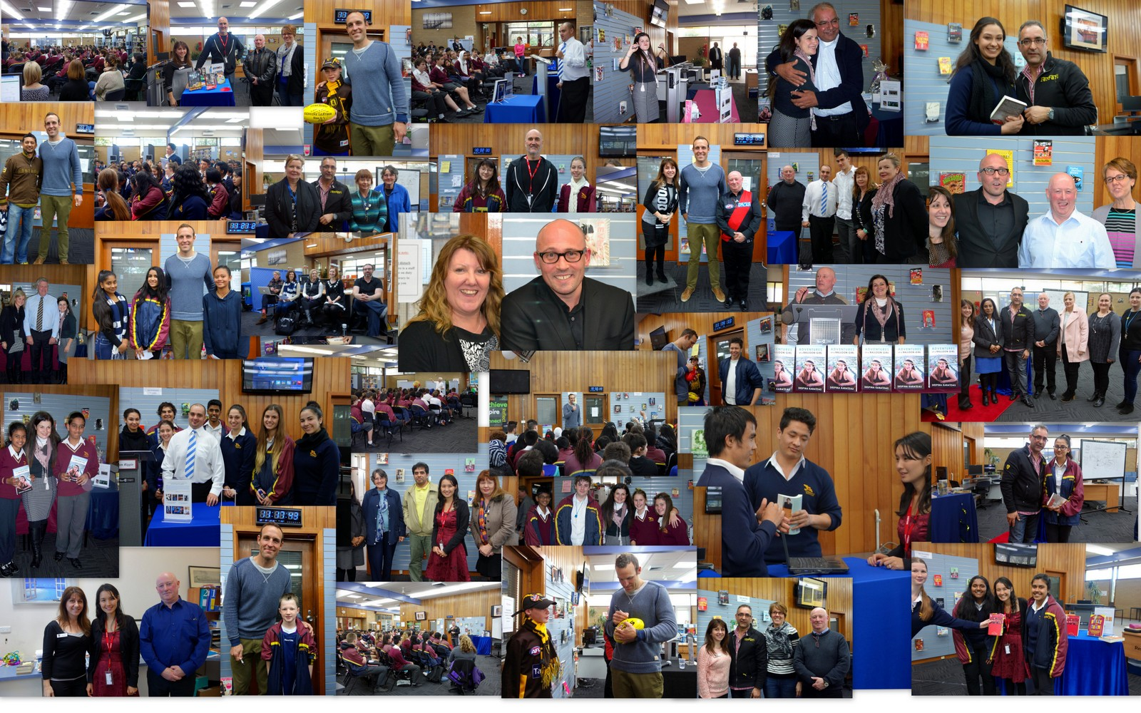

**In its inaugural year** the *Lyndale Library Guest Speaker Program* attracted a combined audience of over 2000 staff and students. The program strives to simultaneously **interest, inform and inspire** our students. Based on the attendance figures and the warm and positive feedback received so far, it is clear that the school has embraced the program. Library staff would like to sincerely thank everyone who has helped us roll out the program this year and we look forward to providing another distinguished cast of guest speakers for the Lyndale community in 2015.

**To** cap off the year Lyndale students turned out in numbers, (and in their club colours) to see triple Geelong premiership player **Brad Ottens** in the College Library.

The 205cm giant was very patient with our students, answering dozens of questions, signing memorabilia and making himself available for photos with students and staff alike. Students Logan Spalding and Mittch Lee both won Sherrin footballs for coming up with the 2 best questions of the morning.

The Buzz  Edition no: 4, Dec. 2014

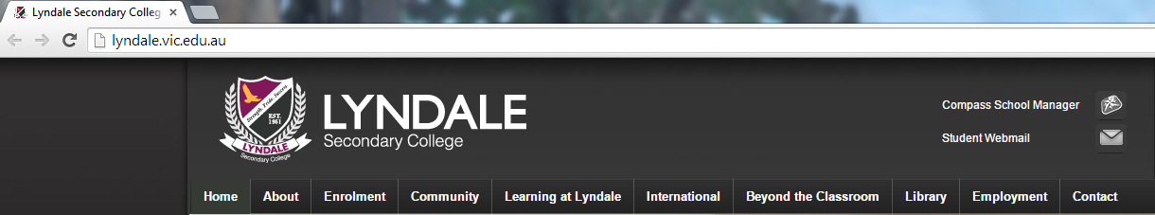

**In the final term** of 2014 the College Library launched a new [Library Website](http://www.lyndalelibrary.org/). You can also access the new website by clicking on the Library menu tab on the **College Homepage** [@ www.lyndale.vic.gov.au](http://lyndale.vic.edu.au/)

,mnjknjklhuo, njkl

**The New Library Website:**

* Gives the library an active presence and identity within the local & global community
* Allows us to communicate and listen to the community we serve
* Allows us to focus on the organisation and delivery of library resources & services that support the needs of students in the 21st century.
* Provides us with a platform for promoting library activities, competitions and events including the Guest Speaker Program so we can reach the widest possible audience

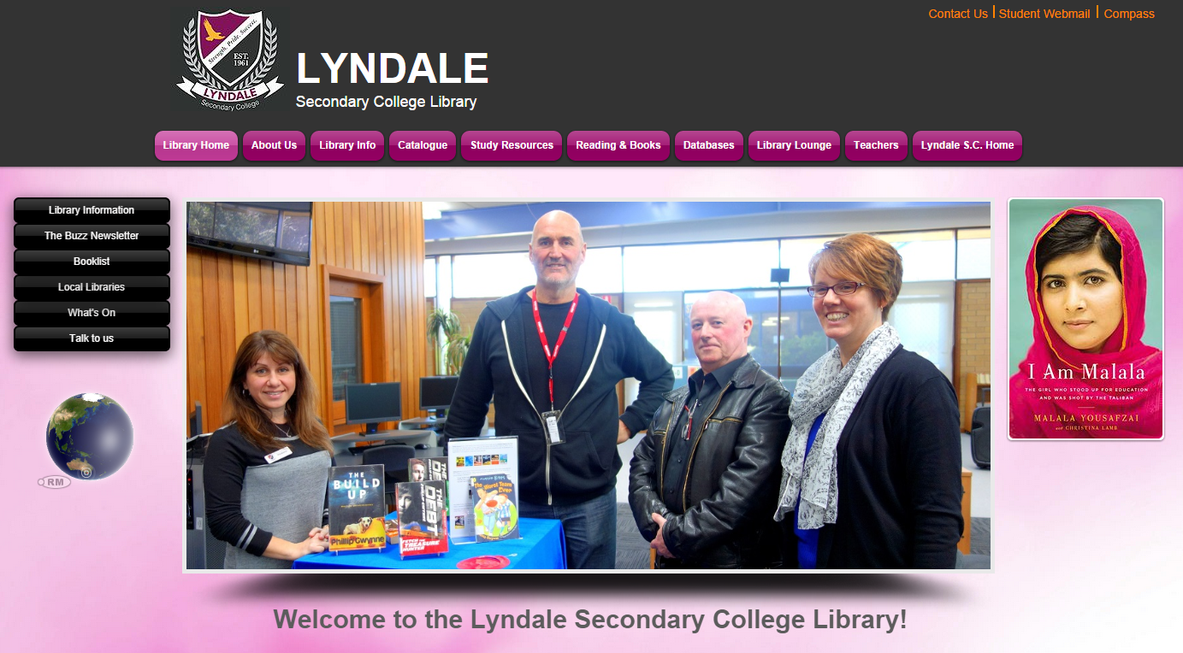

*The new* [*Library Website*](http://www.lyndalelibrary.org/) *(above), designed to suit the information needs of the entire Lyndale community*

The Buzz  Edition no: 4, Dec. 2014

***Through the course of the year*** many of our students and even some of our teachers won prizes. All winners proved to be worthy recipients of their prizes and the high levels of engagement and participation was an encouraging sign for the future.

In 2014 we gave away a number of pairs of Gold Class cinema tickets; loads of great book prizes including signed copies of works by our guest speakers. We gave away several large hampers loaded with all kinds of goodies; we even gave signed copies of Sherrin Footballs to students for coming up with great questions for former Geelong premiership player Brad Ottens.

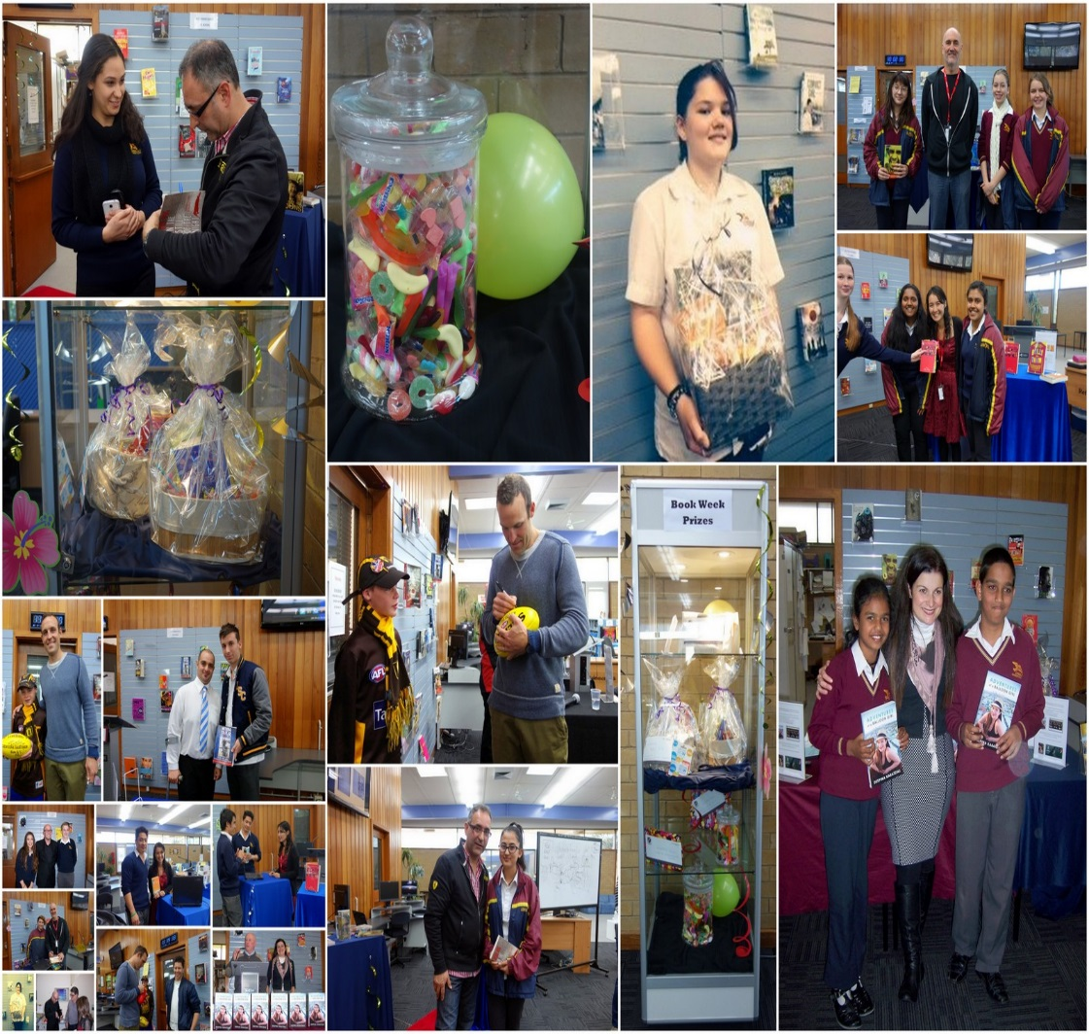

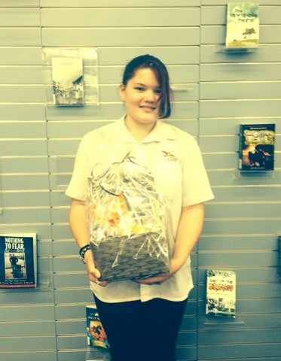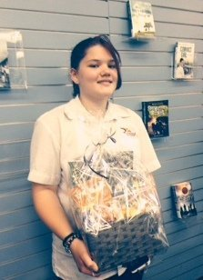



*Library Website Quiz winners: Stop Press congrats to Krishn Lal, Paula Hayes and Marnie Evans. Each receive a copy of the 2014 Booker Prize winning novel The Narrow Road to the Deep North by Richard Flanagan.*

***More College Library in pictures 2014…***

The Buzz  Edition no: 4, Dec. 2014

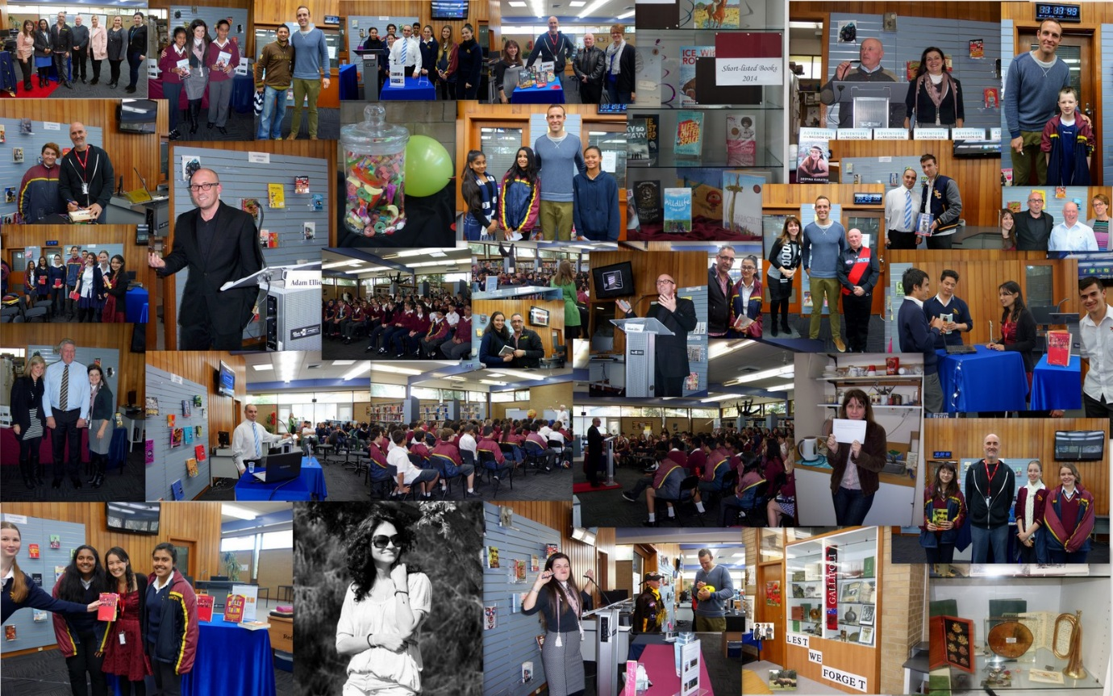

The College Library in 2015?

Based on the support we have had this year we will be powering ahead in the New Year. We are working on plans to continue to grow the profile of the library in order to:

* Promote the College Library as a hub for learning & literacy resources
* Increase student/staff engagement and interaction with the library staff to further learning relationships with students and foster professional/collegiate relationships with staff
* Continue to offer our students and staff opportunities to see and meet interesting, informative, life affirming guest speakers presenting on a diverse range of subjects in the College Library.

*Sincere thanks to everyone who has supported the new direction the College Library has taken this year. Kudos also to my colleague Mary Koutras for her invaluable help in procuring and attending to the needs of our guest speakers this year and for her enthusiasm and persistence in transforming the library space into an attractive and engaging environment for staff and students alike.*

**Heh heh heh…**

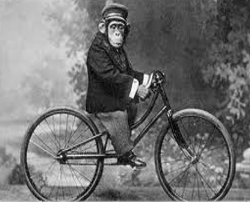

**Here’s hoping you all have a safe, happy Christmas, and a prosperous New-year…**

 BuzZBIZ  with MARY

**Well here we are** approaching another Christmas season. I still remember my first day at Lyndale and I cannot believe that was almost a year ago... Where has this year gone?

What an exciting school to be a part of. I must say I’ve been pleasantly surprised with the wonderful staff and students who make Lyndale what it is. I believe the school has come alive this year- and now with the injection of some long overdue cash from the new State Government maybe we will see our school substantially rebuilt!

In the meantime the library has continued to be a popular place for staff and students. Our private study student numbers tripled over the exam/study period! Despite the sometimes crowded circumstances students frequently sought me out to tell me in person what a nice place the Library was to study in now, this was very encouraging to hear.

**Guest Speakers 2014**

At the beginning of the year we aimed to have 4 guest speakers - we ended up with 8 guest speakers, catering to over 2,000 students from all year levels. Plans are now underway for 2015 and once again we are seeking speakers from all walks of life. It is important to us that we find guests who have something valid and interesting to share with our students.

Stories of overcoming tragic and calamitous events or simply surviving the trials of life in order to achieve worthy personal or career goals was a major theme of the program this year and will also figure prominently amongst our guests next year. Other important themes that we look forward to exploring further include family background and culture and its influence on individual identity; the immigrant experience for new and not so new Australian citizens, and connecting and contributing to the world at large in any number of ways. From simply learning about others through their stories, to saving a rain forest, or helping to combat the spread of the Ebola virus we want our students to be aware that success as an individual can be measured in many different ways.

**New additions to the Library Collection**

This year we established a ***Senior Fiction Collection*** for staff and our more mature readers. A ***Graphic Novel Collection*** was also created and so far it seems that certain students can’t get enough of these novels. Students also appreciate the fact that these works are now located in their own distinct section of the Library and can be easily found or browsed. A ***Teacher Reference Collection*** - another distinct collection within the library designed to assist staff with their teaching and curriculum needs has been significantly weeded and refined to get rid of dated and obsolete reference material. More work to strengthen this collection by adding new and recommended curriculum resources will occur throughout 2015.

**Improvements to the Library Environment** I hope the progress we have made with regard to the appearance of the library environment is apparent to our staff as well as our students. We plan to continue improving the physical space, updating our furniture, equipment and ICT resources where possible so the Library remains a relevant, dynamic and attractive space to work in for the entire school community. Watch this space…!

 BuzZBIZ  with MARY

**To my Library colleagues…**

Finally, A big thank you to my fellow Library colleagues, Andy McLuckie and Sharon Vander Werf. Being the new kid on the block is not always easy but I’ve been blessed with co-operative, supportive colleagues. I have had the pleasure in learning how to develop a website and I must say I am damn proud of Andy and Samantha’s efforts in creating a useful and appealing space for our Library online. I sincerely hope students and staff take advantage of the site as it has been purpose built principally with them in mind.

***Here’s wishing you all a safe and happy Xmas break and a great New Year - see you in 2015!***

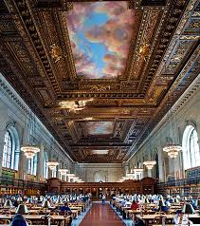



+ **$$$** =



New Lyndale Library???