The Lyndale College Library Guest Speaker Program presents Jan Woszitsky
Jan will be performing his special Lest we forget show in the College Library on ANZAC Day eve during periods 3 and 4 ahead of the public holiday on Friday.
All year 7 teachers are cordially invited to attend. Other staff members who would like to attend are most welcome but please email Andy McLuckie first as seating will be limited.
mcluckie.andrew.a@edumail.vic.gov.au
On the 24th of April the College Library will host the first of a number of special events for 2014.
We are very pleased to announce that our first guest for the year will be Jan (Jarn) Wositzky, musician, storyteller and former singer with the legendary Bushwackers Band. For more details see: http://www.janwositzky.com.au/
Jan is coming to Lyndale to perform two shows for our year seven students.

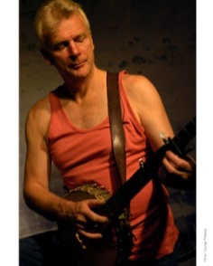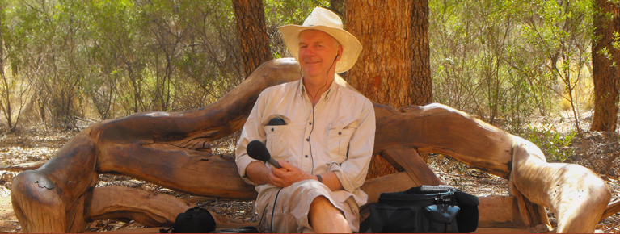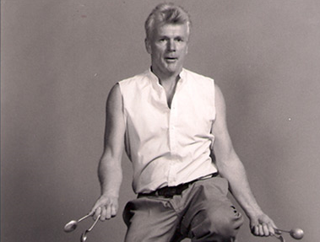

Keep an eye on the What’s On page of our website for more great guest presenters this year.

