The Buzz Edition no: 7, SEPT 2015 edited by Andy McLuckie

Welcome to the third edition of The Buzz for 2015. With Term 3 behind us now, most of this edition focuses on the fun activities, competitions and special guests, that helped make last term our busiest and most productive yet.

In June, Thomas King (Young Victorian Australian of the Year 2015 and VCE Leader of the Year) spoke to our students about the importance of distributed leadership with a particular emphasis on human and animal rights issues.

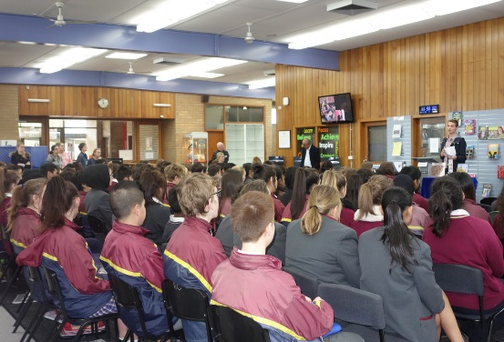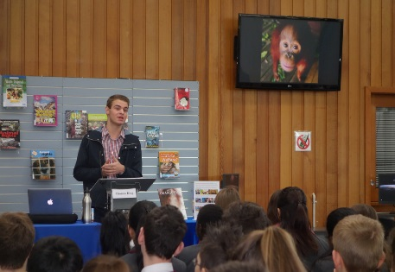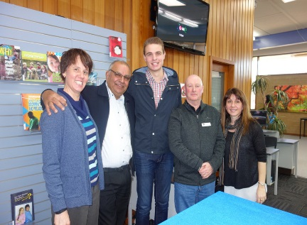
Thomas King addressing Lyndale students and meeting library staff
In July, Melbourne born Olympic Gold medallist Lauren Burns, OAM was warmly received by students and staff alike as she relived some of her Olympic ‘gold moments’ and happily answered a steady stream of student questions on subjects including health, nutrition, fitness and what it takes to make it in sport at the elite level.
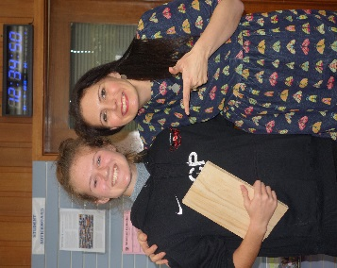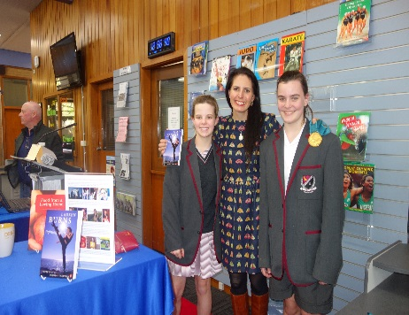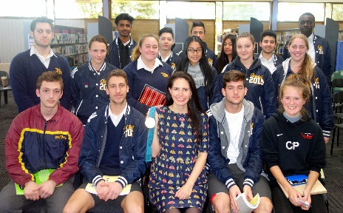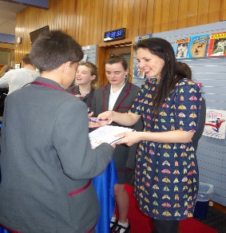
Lauren Burns with some of her Lyndale fans
August ushered in another great season of BookWeek events and competitions culminating with presentations from multi award winning Australian writer Isobelle Carmody, who was in town for Melbourne Writers Festival and Scot Gardner a frequently hilarious and moving speaker with more than a dozen books to his name.
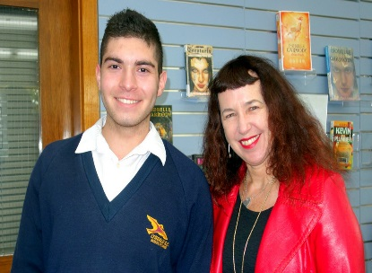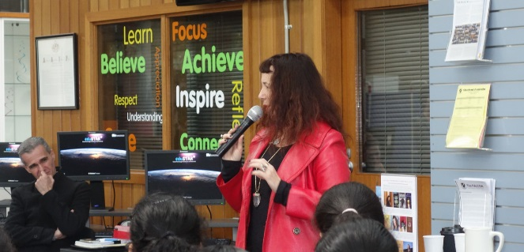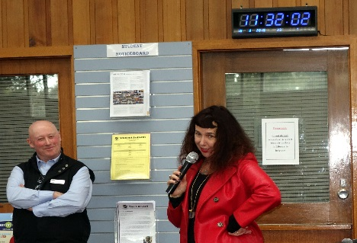
Author Isobelle Carmody at Lyndale August 2015.
Page 1, Issue 7, Sept 2015

The Buzz Edition no: 6, June 2015 edited by Andy McLuckie

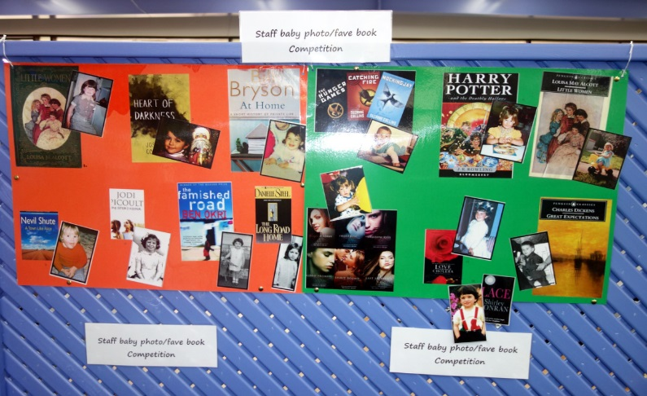
Layal, Voleak and Thuy participating in the Match the teacher to the baby photo & fave book competition.

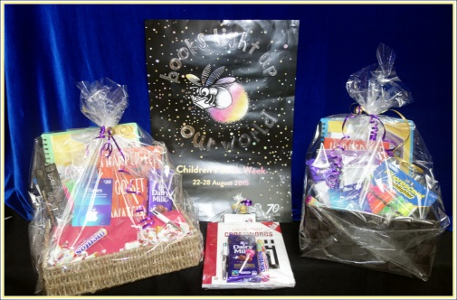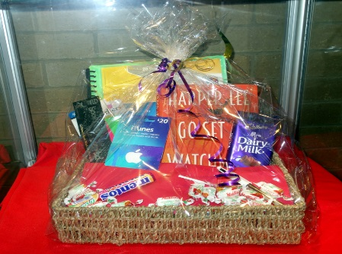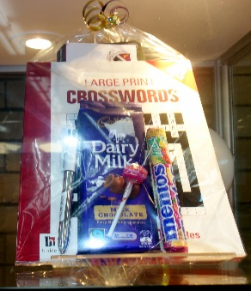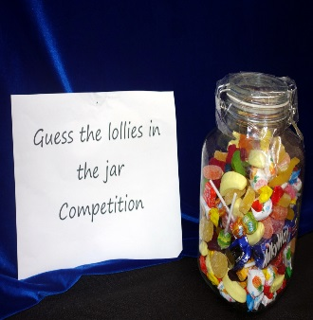
Some of the great hamper prizes that included Harper Lees new book, iTunes and Dymocks book vouchers and lots of chocolate!

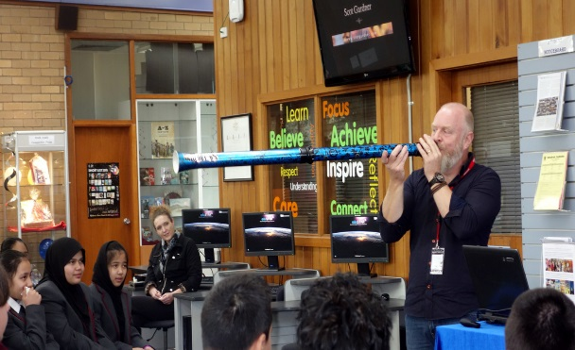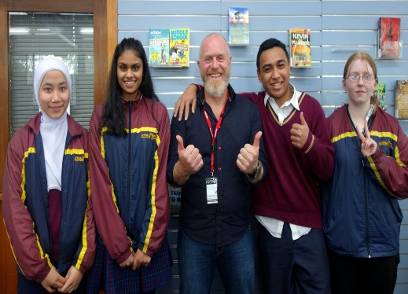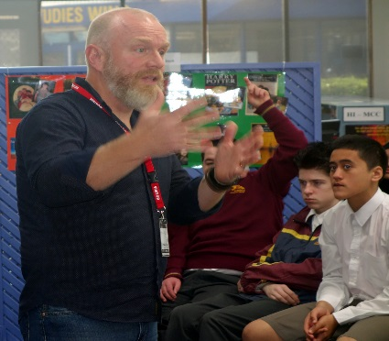
BookWeek author Scot Gardner playing what he call his ‘didgeredon’t’ and ‘chillin’ with some of his Lyndale fans

While the Guest Speaker Program and events such as BookWeek attracted bumper audiences, many students and staff were also enthusiastic in their appreciation of the ongoing improvements taking place in the College Library these days. The improvements are not all cosmetic either – far from it. Continuing on from last year, Library Manager Mary Koutras has revitalised the collection with the inclusion of a huge number of new items including graphic novels, biographies, a senior’s collection, easy reads, new magazine subscriptions, journals and daily and local newspapers in hard copy and digital formats. A great achievement in a short space of time. Onya Mary and a happy and rewarding term 4 to all – Ed.
Page 2, Issue 7, Sept 2015

BuzZBIZ… with MARY

With term 4, upon us, we look forward to sunshine, longer days, footy finals, and a very well-needed break. Term 3 was by far our busiest to date. Book Week activities, competitions and guest speakers kept us on our toes.
It was a delight seeing student interest and involvement in our “match the baby photo to the teacher’s fave book” competition. I think our students got a kick out of seeing their teachers as they once were – babies! Very cute indeed!
The crossword puzzle competition with the theme “books light up our world” had the eager beavers googling away madly to find the answers…..
The “guess the lollies in the jar” had our students hovering over this jar endless discussing, counting, thinking, measuring, begging…..etc. Very entertaining to watch how students come to their crucial decisions. How many lollies were in the jar? The correct answer was 117. Tristan Rios from year 11 was envied by many when he walked out with the lolly jar. Tristan’s guess was 124. Well done, Tristan, I hope this prize does not cause you a trip to the dentist!
The Children’s Book Council of Australia Book of the Year Award for 2015 was awarded to Nona & me by Clare Atkins. This book, along with all the other nominated books can be found in our library currently on display.
New collections: The introduction of the Easy Reads collection has proved popular with our reluctant readers as well as students that find reading more challenging to get into than others. Easy Reads are simple stories with an easy to understand vocabulary that will hopefully entice the reader to continue on with the story until the very last page. These books are shelved separately from the Fiction collection so that students can find them easily.
Alongside these books is our popular Graphic Novel Collection. Judging by the turnover of returns, this collection is well used and will be developed further throughout 2016.
Our Senior students continue to browse the Senior Fiction collection for new additions. Please remember years 7-9 can also borrow from this collection provided a parent approval form has been signed and returned to the library.
Page 3, Issue 7, Sept 2015
BuzZBIZ… with MARY

The silent reading area has become a popular spot at recess and lunch times. More often than not our comfy lounge chairs are now filled with students from all year levels with their heads buried deeply in a book, a magazine or even a newspaper. This is a welcoming sight and I will continue to add to the magazine collection in the coming months. All suggestions and feedback is most welcome.
For our Literacy teaching staff….
The Picture Book Collection has been relocated to the new display area for your convenience. Picture books can now be viewed through the glass display and teachers are encouraged to borrow from this fantastic collection as a source of material for your literacy classes. Picture books can be deceptively simple stories with a strong message. Illustrations are detailed and richly informative and great discussion starters to use with your class. One of my personal favourites that we recently added to this collection is Suri’s Wall a beautifully written book with superb illustrations and a surprising twist at the end. It would certainly create group discussion amongst your literacy group.
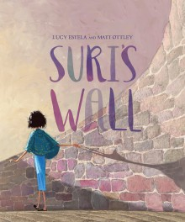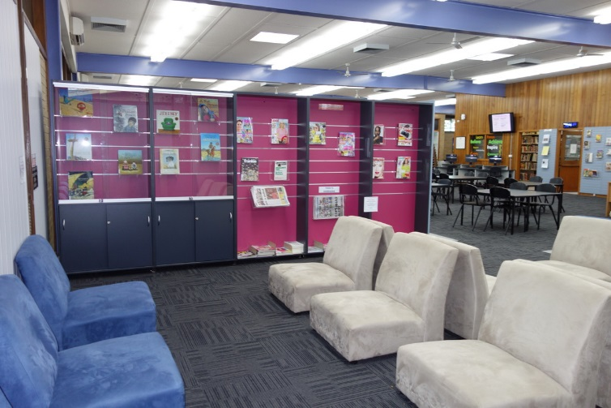
Suri’s Wall can be found on display in our Picture Book Collection as featured above

Well that’s a wrap up from me. To all Lyndale staff and students, hope you have a fantastic Final Term …. Mary
Page 4, Issue 7, Sept 2015

